REPUBLIC OF CAMEROON
Peace-Work-Fatherland

AFRICAN INSTITUTE OF COMPUTER
SCIENCES-CAMEROON PAUL BIYA
TECHNOLOGICAL CENTER
OF EXCELLENCE
P.O. Box: 13719 Yaoundé
Tel: +237.242.729.957 Fax: 22729958
Email: conatct@iaicameroun.com
Site web: www.iaicameroun.com
REPUBLIQUE DU CAMEROUN
Paix-Travail-Patrie



REALIZE

Tel : +237 620256960 / 237 654486985
Email : realize.contactus@gmail.com
Web site : www.realize.com

REPUBLIQUE DU CAMEROUN
Paix-Travail-Patrie

REALIZE
Tel: +237 620256960 / 237 654486985
Web site: www.realize.com
Email: realize.contactus@gmail.com



ACADEMIC INTERNSHIP REPORT

THEME: CONCEPTION AND REALIZATION OF A SERVICE DELIVERY MOBILE APPLICATION
Case Study: Food Delivery

Internship carried out from 1st July 2025 to 30th September 2025 at the company REALIZE as part of my pursuit to obtain a Higher Technician Diploma (HTD) in Computer Science
Option: Software Engineering

Written By:
TANGOMO TCHAPDU CHRIST PUJALTE
Level II Student at AICS Cameroon

Supervisors

Professional Supervisor:
Mrs. CHAYIE LUCRESE
Software Engineer at REALIZE
Academic Supervisor:
Mr. NDIFOR ROGER
Lecturer At AICS Cameroon

ACADEMIC YEAR
2024-2025

DEDICATION

This work is dedicated to the TANGOMO’s family for their love and unconditional sacrifices for my academic success

ACKNOWLEDGEMENTS

This work wouldn’t have been a success without the important contributions of a good number of people who took it upon themselves to see this work accomplished. Our sincere gratitude goes to the following:
- Mr. ARMAND CLAUDE ABANDA, the resident representative of ACIS Cameroon, for his guidance and support throughout these years.
- The chief executive officer of Realize, Mr. NDELOGAKEH Daniel, and his staff for trusting us by allowing us to serve as interns in their prestigious enterprise.
- The director of the IT Department at Realize, Mr. TANUE MONETTE, and his staff for accepting us as interns in his institution.
- Our professional supervisor, Mrs. CHAYIE LUCRESE, for her moral support, advice, and professional expertise, which he shared with us.
- To my academic supervisor, Mr. NDIFOR ROGER, for his availability, advice, moral support, and follow-up throughout this period.
- To our supervisors, Mr. PERCY, Mr. KAMENI CHRIST, Mrs. SANDRA, and Mr. MENGOT for their advice and follow-up.
- To our academic teachers, Mr. MESSIO ULRICH, Mrs. TCHOUTOUO ISABELLE, AND Mr. AGBOR ANDERSON, for their advice and assistance in realizing this document.
- To all the professorial and administrative core members at AICS CAMEROON for their professionalism, love, support, and counselling.
- To my parents (Mr. AND Mrs. TANGOMO), and brothers for their limitless love and support, their faith in us and our abilities, and their encouragement.
- To my grandmother for her love, patience, support, counselling, and faith in our abilities.
- To the TCHAPDU and NJIADJO family for their patience, attention, and counselling.
- To all my brothers and sisters for their love and support.
- To our lovely friends and Classmates, for their limitless love and support, their faith in our abilities, and their encouragement throughout this year.

CONTENT

DEDICATION i
ACKNOWLEDGEMENTS ii
CONTENT iii
LIST OF TABLES iii
LIST OF FIGURES v
ABBREVIATIONS vii
GLOSSARY viii
ABSTRACT ix
RESUME x
GENERAL INTRODUCTION 1
PART 1: INSERTION PHASE 2
PART 2: TECHNICAL PHASE 14
FILE 1 : EXISTING SYSTEM 16
FILE 2 : THE SPECIFICATION BOOK 26
FILE 3: ANALYSIS PHASE 44
FILE 4 : CONCEPTION PHASE 80
FILE 5 : REALIZATION PHASE 95
FILE 6: FUNCTIONALITY TESTING PHASE 105
FILE 7 : THE USER GUIDE 114
PERSPECTIVES 121
GENERAL CONCLUSION 123
ANNEXES x
BIBLIOGRAPHY xi
WEBOGRAPHY xiv
VIDEOGRAPHY xv
TABLE OF CONTENTS xvi

LIST OF TABLES

Table 1: Hardware resources 11
Table 2: Software resources 11
Table 3: Limitations, Consequences and Proposed Solutions 21
Table 4: Chronogram of activities 36
Table 5: Software Resources (source: Mercurial-2024) 39
Table 6: Hardware Resources (source: Mercurial-2024) 40
Table 7: Human Resources (source: Mercurial-2024) 40
Table 8: Global Estimation of Project 41
Table 9: List of Participants 43
Table 10: Comparison Between MERISE and UML 49
Table 11: Components of a Use case Diagram 55
Table 12: Primary Actors of Our System 56
Table 13: Textual Description Formalism 60
Table 14: Textual description of Authenticate 61
Table 15: Textual decsription of Create Account(client) 62
Table 16: Textual description of Create Account (DeliveryAgent and Partner) 63
Table 17: Textual decsription Place Order 64
Table 18: Components of a communication diagram 66
Table 19: Components of a Sequence diagram 70
Table 20: Components of an Activity diagram 75
Table 21: Components of a class diagram 86
Table 22: Components of a state machine diagram 89
Table 23:Component of a package diagram 92
Table 24: Components of a deployment diagram 99
Table 25: Components of a component diagram 102

LIST OF FIGURES

Figure 1: Localization plan of Realize 7
Figure 2: Functional organization of Realize 10
Figure 3: Gantt Project 38
Figure 4: UML 2.5 diagrams overview (source: https://creately.com/blog/diagrams/uml-diagram-types-examples/) 48
Figure 5: UML 2.5 diagrams overview (source: https://creately.com/blog/diagrams/uml-diagram-types-examples/ ) 48
Figure 6: Two Track Unified Process (source: https://www.mysciencework.com/omniscience/pervasive-mobile-healthcare-system-basedon-cloud-computing) 51
Figure 7: Use Case Formalism 54
Figure 8: General Use case Diagram 58
Figure 9: Browse menu Specific Use case 59
Figure 10: Track Order Specific UseCase 59
Figure 11: Communication diagram formalism 65
Figure 12: Communication diagram of Create Account 67
Figure 13: Communication diagram of Authenticate 67
Figure 14: Communication diagram of Place Order 68
Figure 15: Sequence diagram Formalism 69
Figure 16: Sequence diagram of Authenticate 71
Figure 17: Sequence diagram of Create Account 72
Figure 18: Sequence diagram of Place Order 73
Figure 19: Activity Diagram Formalism 74
Figure 20: Authenticate Activity diagram 77
Figure 21:Create Account Activity diagram 78
Figure 22: Place Order Activity diagram 79
Figure 23: Physical Architecture diagram 83
Figure 24: Logical Architecture 84
Figure 25: Class diagram formalism 85
Figure 26: EaseDrive Class diagram 86
Figure 27: State machine diagram formalism 88
Figure 28: Account state machine diagram 90
Figure 29: Package diagram formalism 91
Figure 30: EaseDrive package diagram 93
Figure 31: Deployment diagram formalism 98
Figure 32: EaseDrive deployment diagram 100
Figure 33: Component diagram formalism 101
Figure 34: EaseDrive component diagram 103
Figure 35: User registration code test snippets 110
Figure 36: User registration unit test result 111
Figure 37: Authentication test code snippet 111
Figure 38: Registration Unit test result 112
Figure 39: EaseDrive Signup screen 120
Figure 40: EaseDrive onboarding screen 119
Figure 41: EaseDrive Login Screen 120
Figure 42: EaseDrive client Homescreen 121

ABBREVIATIONS

- 2TUP: Two Track Unified Process
- AICS: African Institute of Computer Science
- API: Application Programming Interface
- CSS: Cascading Style Sheet
- DBMS: Database Management System
- DSEI: Digital Smart Egg Incubator
- HTML: Hypertext Markup Language
- HTTP: Hypertext Transfer Protocol
- IDE: Integrated Development Environment
- LCD: Liquid Crystal Display
- MVC: Model View Controller
- OS: Operating System
- PIR: Passive Infrared
- UML: Unified Modelling Language
- URL: Universal Resource Location
- USB: Universal Serial Bus

GLOSSARY

- GPS: A Global Positioning System (GPS) is a satellite-based navigation system that provides location, velocity, and time information to users worldwide.
- Framework: In computer programming, a framework refers to a coherent set of structured software components used to create the foundations and outlines of all or part of a software application.
- Computer Science: Computer science is a scientific, technical, and industrial field concerning the automatic processing of digital information through the execution of computer programs by machines such as embedded systems, computers, robots, automata, etc.
- Software: In computing, software refers to the set of programs, procedures, and associated documentation that enable a computer to perform specific tasks.
- Data: Data is what is known and serves as a starting point for reasoning aimed at determining a solution to a problem related to this data.
- Database: A database allows for the storage and retrieval of structured, semi-structured, or raw data, often related to a specific theme or activity; these can be of various types and interconnected.
- Application Programming Interface (API): An API is a standardized set of classes, methods, functions, and constants that serves as a facade through which a software offers services to other software.
- Technology: Technology is the study of tools and techniques. The term refers to observations on the state of the art at various historical periods, in terms of tools and expertise. It includes art, craftsmanship, trades, applied sciences, and sometimes knowledge.
- Programming Language: A programming language is a notation designed to formulate algorithms and produce computer programs that apply them

ABSTRACT

Cameroon, with its population of over 28 million people, is experiencing rapid urbanization and increasing demand for reliable delivery services. Despite a vibrant cultural heritage and one of the richest culinary diversities in Central Africa, many local restaurants and food vendors lack digital presence, making it difficult for customers to access their meals conveniently. At the same time, delivery processes often remain inefficient, with limited real-time tracking and unreliable logistics systems. To address these challenges, we developed EaseDrive, a mobile application designed to connect customers, partners, and delivery agents on a single digital platform. The app enables users to place and track delivery requests in real time, while partners can showcase their services digitally and manage customer orders with greater transparency. Delivery agents benefit from an organized task management system, ensuring timely and reliable services. The system was analyzed using UML and designed with the 2TUP (Two Tracks Unified Process) methodology, before being implemented with the MERN stack (MongoDB, Express.js, React Native, Node.js). The solution aims to modernize delivery services in Cameroon by bridging the gap between cultural richness and technological accessibility, ultimately improving logistics efficiency and customer satisfaction.
Keywords:
- Ease Drive
- Culinary diversity
- Delivery
- Informal Food Sector
- Real-time tracking
- Local Restaurants
- Order management
- Geolocalization

RESUME

Le Cameroun, avec une population de plus de 28 millions d’habitants, connaît une urbanisation rapide et une demande croissante pour des services de livraison fiables. Malgré un patrimoine culturel riche et l’une des plus grandes diversités culinaires d’Afrique centrale, de nombreux restaurants et vendeurs de repas locaux restent sans présence numérique, rendant l’accès à leurs plats difficile pour les consommateurs. Par ailleurs, les processus de livraison demeurent souvent inefficaces, avec un suivi en temps réel limité et des systèmes logistiques peu fiables. Pour répondre à ces défis, nous avons développé EaseDrive, une application mobile conçue pour connecter les clients, les partenaires et les livreurs sur une plateforme numérique unifiée. L’application permet aux utilisateurs de passer et de suivre leurs commandes en temps réel, tandis que les partenaires peuvent présenter leurs services en ligne et gérer les commandes des clients avec plus de transparence. Les livreurs bénéficient quant à eux d’un système d’organisation des tâches, garantissant des services ponctuels et fiables. Le système a été analysé à l’aide de l’UML et conçu selon la méthodologie 2TUP (Two Tracks Unified Process), avant d’être implémenté avec le MERN stack (MongoDB, Express.js, React Native, Node.js). La solution vise à moderniser les services de livraison au Cameroun en comblant le fossé entre la richesse culturelle et l’accessibilité technologique, tout en améliorant l’efficacité logistique et la satisfaction des clients.
Keyword :
- EaseDrive
- Diversité culinaire
- Livraison géolocalisée (GPS)
- Partenaires restaurants locaux
- Suivi en temps réel
- Gestion des commandes
- Géolocalisation

GENERAL INTRODUCTION

Cameroon, often described as “Africa in miniature,” is endowed with remarkable cultural diversity and abundant natural resources, yet it continues to face persistent socio-economic challenges that affect both individuals and organizations in their daily lives. These realities increasingly call for innovative solutions capable of improving efficiency, accessibility, and sustainability in various sectors. Over time, computer science has proven to be a powerful driver of such change, offering tools and systems that not only address practical needs but also contribute to broader societal development. With this perspective in mind, the African Institute of Computer Sciences (AICS) places strong emphasis on projects that allow students to apply their academic knowledge to real-world contexts while supporting organizations in overcoming operational challenges. It is within this framework that the company REALIZE, a software development firm dedicated to sustainable and innovative digital solutions, assigned to us the theme: “CONCEPTION AND IMPLEMENTATION OF A SERVICE DELIVERY MOBILE APPLICATION.” The work was structured into eight phases, which are:
- Insertion Phase: Here we shall talk about our host company, their services, mission, as well as our first two weeks at our host company.
- Existing System: Here, we shall present the existing system in place, that is, the one used for consultation and follow-up purposes.
- Specification Book: In this book, we specify the needs of the user, taking into consideration the time and cost of the project.
- Analysis Document: Here, we shall present the analysis method chosen, together with the presentation of all the diagrams used for the analysis of this project.
- Conception phase: This presents the generic and detailed conception of the project to bring out real-world constituents.
- The Realization phase: This phase will permit us to visualize the implementation process of the solution.
- Test of functionalities: In this phase, we shall present to you the different functionalities or modules of our application and how they work.
- The User Guide: This elaborates on all conditions necessary to use the application and how to use it.

PART 1: INSERTION PHASE

Preamble

The insertion phase document presents the internship environment, the structure of the organization, the conditions in which the interns were received, as well as the project to be realized during the internship.

Content
INTRODUCTION
- WELCOME AND INTEGRATION
- GENERAL PRESENTATION OF REALIZE
- ORGANIZATION OF REALIZE
- HARDWARE AND SOFTWARE RESOURCES
- BRIEF PRESENTATION OF THE PROJECT
CONCLUSION

INTRODUCTION
The insertion phase marked my first glimpse into both professional and general realities when we began working as an intern. Throughout this phase, we familiarized ourselves with the reception structure, comprehended its operation, researched administrative necessities to better understand the predicaments facing us, and ultimately resolved an issue that was compliant with the structure's demands. The proposed insertion phase report details our initial foray into the professional world, particularly within REALIZE. It delayed a period of 2 weeks, focusing on REALIZE and its structure, along with the introduction of my host unit the Software Engineering department and my seamless assimilation into the internship program there.

WELCOMING AND INTEGRATION
We arrived at REALIZE on Tuesday, July 1, 2025, at 8:00 a.m. Our first point of contact was the director of the IT department, Mr. Tanue Monette, who welcomed us and introduced us to our workspace. He provided an overview of the company's activities, rules, and regulations. During this time, we also had a discussion about the preferred languages and frameworks used by the enterprise. Our professional supervisor shared insights from his previous experiences in various companies, offering encouragement as we embarked on our journey.

After settling into our designated workstations, we were promptly assigned our first task for the day. During the first week, we conducted a verification of concepts using fundamental HTML and CSS to ensure everyone was on an even playing field before progressing. We then engaged in discussions about project ideas, where we were encouraged to propose our own. My previous experience made it easier to contribute and refine these ideas. Subsequently, we were tasked with researching these ideas, as the enterprise valued our initiative and did not impose any themes on us.
In the second week, we focused on JavaScript concept verification exercises to assess our understanding and reasoning skills. We held a detailed discussion with our professional supervisor about the specification book and its various components, where he outlined what was expected of us in each segment. We also continued developing our project ideas into a concrete plan, benefiting from my previous familiarity with the company's expectations and processes.

Background
Realize is a Cameroon digital start-up institute founded by Mr. NDELOGAKEH Daniel in 2022, which proposes IT solutions and empowers the use of new technologies in Cameroon

GENERAL PRESENTATION OF REALIZE

Missions, Visions, and Activities of Realize

Missions:
The mission of Realize mainly relates to the empowerment and the perpetuation of Technology use. These missions include:
● Design and realize mobile-oriented software for companies and individuals;
● Assist newborn companies for quick growth using computer science;
● Provide training and certifications to improve qualified human resources in many fields of study;
● Take an active part in the sustainable development of the world through innovative solutions and virtual reality.

Vision:
At Realize, we believe that the true potential of every organization and individual can be unlocked through the harmonious fusion of analysis, development, realization, and data analytics. Our vision propels us forward, guiding us to make a lasting impact on the digital landscape and shape a future where innovation knows no bounds."

Activities:
The activities of Realize range from computer science, engineering, and training. We can outline the following:
● Conception, realization, and hosting of websites;
● Software development and maintenance;
● Training in software-related fields;
● Conception and realization of multimedia;
● IT consulting and innovation
● IT support

Localization
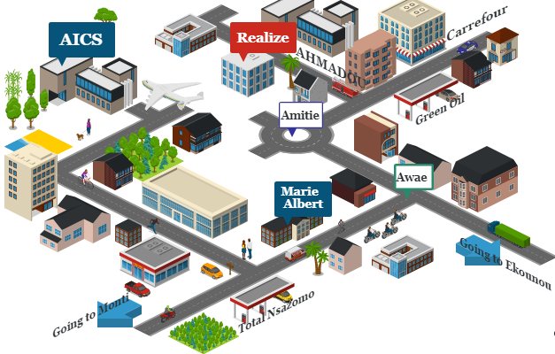
Figure 1: Localization plan of Realize

ORGANIZATION OF REALIZE

Administrative organization
Realize if administratively organized as follows:

The General management
This is the highest level of the company, which takes care of the following:
- Proper functioning of each department.
- Define project strategies.
- Provide leadership and guidance to the company’s employees.
- Makes critical decisions that could affect the company’s operations or reputation
- Severe as a point of contact for key stakeholders such as investors, etc.

Human resource department
This department is in charge of the following:
- Recruitment and Hiring
- Acts as a liaison between employees and management;
- Manages employee compensation and benefits programs;
- Develops and implements company policies and procedures, ensuring compliance with employment laws and regulations.
- Manages administrative tasks related to employee records, data management, and HR systems

Communication Department
This department is in charge of the following:
- Handles public relations activities, which involve managing the company’s reputation and image;
- Responsible for crafting and delivering messages to external stakeholders such as customers etc...
- It fosters effective communication within the company.
- They create and manage content across different platforms and channels;

Department of Financial Affairs
This department is in charge of the following:
- Responsible for developing and managing the company’s financial plans and budgets;
- Prepare and present accurate and timely financial reports to management, stakeholders, and regulatory authorities;
- Responsible for managing costs and expenses within the organization.
- Ensures compliance with tax laws and regulations. Etc.

Technical department
This department is in charge of the following:
- Responsible for managing the company’s technological infrastructure, including networks and hardware.
- Play a role in managing and maintaining the company’s data;
- Responsible for implementing and maintaining cybersecurity measures to protect the company’s digital assets from potential threats;
- Interacts with technology vendors and manages relationships with external service providers. Etc.

Software Engineering Department
This department is in charge of the following:
- Primarily responsible for developing software applications and systems;
- Responsible for maintaining and supporting software applications throughout their lifecycle;
- Evaluation and realization of projects, etc.

FUNCTIONAL ORGANIZATION OF REALIZE
The functional branch of Realize is organized as follows
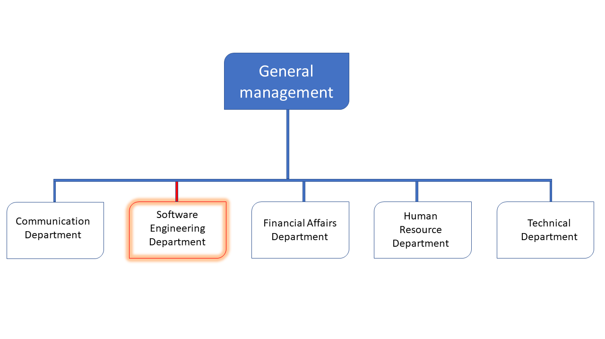
Figure 2: Functional organization of Realize

HARDWARE AND SOFTWARE RESOURCES

HARDWARE RESOURCES
Table 1: Hardware resources
No | DESIGNATION | QUANTITY | CHARECTERISTICS | OBSERVATION
1 | MacBook Pro | 1 | APPLE | Good
2 | Modem | 1 | CAMTEL | Good
3 | LCD Screen | 1 | HP | Excellent
4 | Training equipment and office furniture | / | /

SOFTWARE RESOURCES
Table 2: Software resources
DESIGNATION | SOFTWARE
Operating System | Windows 10, Mac OS, Parrot Linux
Design tools | Photoshop
Integrated development environment (IDE) | Visual Studio Code
Text editor | Sublime text, notepad++
Database management system (DBMS) | MongoDB, PostgreSQL, MySQL
Web browser | Google chrome, Microsoft edge
Document editor | Microsoft Office Word

BRIEF PRESENTATION OF PROJECT
At the end of the initial two weeks (insertion period), we received a topic, namely CONCEPTION AND REALISATION OF A SERVICE DELIVERY APP. This project entails the development of a comprehensive digital platform designed to seamlessly connect customers requiring diverse delivery services with verified providers and couriers.
The primary objective of the application is to streamline the entire service delivery lifecycle – from instant booking and real-time tracking to secure payment and feedback, creating an efficient, transparent, and user-friendly experience for both end-users (customers) and service providers.

CONCLUSION
Our integration into the company was a pleasurable experience, with friendly and approachable colleagues and a professional supervisor who made us feel welcomed. Their availability and smooth integration into the company's operations were commendable. One of the most valuable takeaways from this phase was the importance of collaboration and discipline, crucial to any successful career. The subsequent phase of this momentous journey involves the project specifications, which must be precise and succinct to comprehensively understand what is needed to extract the most value from this transformative project.

PART 2: TECHNICAL PHASE

Preamble

The Technical phase helped us to establish a comprehensive understanding of the host organization. This phase emphasizes on the key characteristics, specificities, and objectives of the designated study subject.

Content:
INTRODUCTION
- The Existing System
- The Specification Book
- The Analysis Phase
- The Conception Phase
- Deployment or Realization Phase
- The Functionality Phase
- The User Guide
CONCLUSION

FILE 1 : EXISTING SYSTEM

Preamble

The existing system refers to the established processes currently used. This documentation outlines how these processes function, including their limitations and any resulting problems. We aim to address these issues by proposing a new solution.

Content
INTRODUCTION
I. PRESENTATION OF THE PROJECT
II. DESCRIPTION OF THE EXISTING SYSTEM
III. CRITICISM OF THE EXISTING SYSTEM
IV. PROBLEMATIC
VI. PROPOSED SOLUTIONS
CONCLUSION

INTRODUCTION
In this part of our report, we will explain our theme. We will also study the current system and identify its strengths and weaknesses. Based on this analysis, we will present the problem statement, which is the main challenge or gap that the current system faces. Finally, we will propose a solution that addresses this problem and improves the system.

PRESENTATION OF THE PROJECT
EaseDrive is a Cameroonian-built food delivery platform designed to improve food accessibility, restaurant visibility, and customer experience across urban and semi-urban areas of Cameroon. Key distinguishing features:
- 100% Cameroonian ownership and operation: the platform is developed, maintained, and governed locally to respond to national market realities and support local economic growth.
- Local Flavors section: a dedicated area of the app highlighting traditional Cameroonian dishes, culinary stories, and recommended meals for tourists looking to explore local cuisine.
- Dual merchant model: the platform seamlessly supports restaurants and food vendors that have their own delivery agents as well as those without delivery capacity (by providing integrated dispatch and rider assignment services).
- User-friendly mobile and web interfaces for customers, restaurants, and delivery agents.
- KYC verification for merchants and delivery agents to build trust and safety.
- Multiple payment options, including mobile money, bank cards, and defined cash handling workflows for cash-on-delivery.

DESCRIPTION OF THE EXISTING SYSTEM
The current food ordering and delivery environment in Cameroon remains largely manual and fragmented. Many small restaurants and food vendors rely on phone calls, WhatsApp, or walk-ins to receive orders, while deliveries are often organized informally. A few tech startups operate in major cities, but coverage is uneven, and many merchants, especially those selling traditional dishes, are not represented online.
Important notes relate to the Cameroonian context:
- Digital representation of local cuisine is limited: many vendors who sell traditional Cameroonian meals (e.g., ndolé, koki, eru, poisson braisé, achu) lack visibility on existing platforms.
- Mixed delivery capacity: some restaurants employ their own riders, while many small vendors do not have delivery resources and depend on customers coming to pick up orders or informal couriers.
- Cash remains a dominant payment method; mobile money is growing, but reconciliation is inconsistent.
- Customer trust in delivery quality varies due to lack of standardized reviews, KYC checks, and tracking.

LIMITATIONS OF THE EXISTING SYSTEM
Table 3: Limitations, Consequences and Proposed Solutions
LIMITATIONS | CONSEQUENCES | PROPOSED SOLUTION
Low representation of Cameroonian culinary diversity on digital channels | Poor showcasing of local dishes makes tourists and new users miss authentic options, reducing orders for traditional vendors, weakening overall market differentiation, and keeping small vendors invisible. | Create a Local Cuisine Hub with a tourist-friendly UI, merchant onboarding for photos/origins/allergens, pro photography support, and SEO-optimized dish pages with weekly spotlights.
Fragmented delivery arrangements | Many small restaurants lack delivery, limiting their reach and sales. While customers face inconsistent quality and coverage, this reduces trust and hinders uniform platform growth. | Implement a hybrid delivery model with agent aggregation, pooled pick-ups and flexible scheduling with dynamic fees.
Poor Tracking and limited customer Feedback | Weak tracking and feedback mechanisms cause cancellations, disputes between parties, and lower customer retention. | Provide real-time tracking, proof of delivery, in-app communication, quick post-delivery ratings, and dashboards for merchants.
Heavy reliance on cash | Because most transactions are cash-based, this poses a risk because carrying cash also increases theft and security threats for drivers and vendors. | Integrate mobile money and card payments, use escrow with auto-settlement, limit cash-on-delivery, and add safety and fraud-control features
Limited support for vendors with different operational models | A one-size-fits-all workflow creates order errors, cancellations, and merchant churn while wasting delivery resources. | Enable merchant profiles for self, platform, or hybrid delivery, add flexible order lifecycles, offer POS/API integrations, and provide training and incentives

PROBLEMATIC
HOW CAN WE BUILD A 100% CAMEROONIAN FOOD DELIVERY PLATFORM THAT INCREASES VISIBILITY FOR LOCAL CUISINE (ESPECIALLY FOR TOURISTS), SUPPORTS MERCHANTS REGARDLESS OF WHETHER THEY HAVE DELIVERY AGENTS, AND IMPROVES RELIABILITY, TRACEABILITY, AND ECONOMIC OPPORTUNITY ACROSS CAMEROON?

PROPOSED SOLUTION
To address the challenges identified, we propose developing a comprehensive EaseDrive Platform. This application will provide a centralized solution for discovering, ordering, and managing Cameroonian cuisine, enhancing efficiency, accessibility, and user satisfaction.
- Local-First Strategy: EaseDrive will remain locally owned and operated to ensure cultural relevance, faster response to market needs, and reinvestment into the local economy.
- Dedicated “Local Meals” Section: The platform will highlight traditional dishes with descriptions, origin stories, suggested pairings, and tourist-friendly recommendations.
- Dual Merchant Workflow: Merchants with delivery agents will have tools for scheduling, rider management, and optional route optimization, while merchants without delivery agents will be supported by platform-dispatched riders through a simple onboarding flow.
- Flexible Payments: EaseDrive will support mobile money, bank cards, and supervised cash-on-delivery, with reconciliation tools to ensure accountability.
- Trust & Safety: KYC verification for merchants and riders, customer ratings, and structured dispute-resolution workflows will be implemented to enhance security and reliability.
- Lightweight Tracking & Offline Resilience: GPS tracking for riders, SMS/WhatsApp notifications, and offline-first features will ensure service continuity even in areas with intermittent connectivity.
- Promotion and Partnerships: Strategic collaborations with tourism boards, guesthouses, and hotels will promote local dishes and regional specialties to both domestic and international users.

CONCLUSION
The project theme plays a crucial role in establishing the work scope and identifying the system. Conducting a thorough analysis of the present system is equally important to understand its limitations and existing issues, prior to implementing any improvements. Once the analysis is done, we can frame the problem and offer a well-formulated solution to tackle the identified issues.

FILE 2 : THE SPECIFICATION BOOK

Preamble

This is a document that frames the student’s academic internship, specifies the behavior of the student during his internship. This stage involves organization, planning, pedagogical standards, and monitoring of work. It is considered a communication and description tool that permits us to avoid inadequate results.

Content
INTRODUCTION
- CONTEXT AND JUSTIFICATION OF PROJECT
- OBJECTIVES OF THE PROJECT
- EXPRESSION OF NEEDS
IV PROJECT PLANNING
- ESTIMATED COST OF PROJECT
VI PROJECT CONSTRAINTS
VII PARTICIPANTS
VIII. DELIVERABLES
CONCLUSION

INTRODUCTION
The report's specification book enables us to provide comprehensive details about our topic, enhancing our understanding and improving its chances of success. To establish the project's scope, we will describe the context of our topic and identify the issues within it that we aim to solve. Once the solution is proposed, we will outline the objectives we have set for ourselves and for the project. Also, we will assess the functional and non-functional requirements of our system before designing a plan to ensure the timely completion of the project and determine the financial resources needed. Subsequently, we will outline the expected project deliverables at the conclusion of the project.

CONTEXT AND JUSTIFICATION

CONTEXT:
In today’s urban lifestyle, the demand for reliable and efficient delivery services has become increasingly pressing. As populations in Cameroonian cities continue to grow, people are looking for faster and more convenient ways to access meals, groceries, and everyday essentials without always needing to move physically.
The current systems in place are still largely manual and fragmented. Customers often have to call restaurants directly, rely on informal delivery agents, or even travel themselves to pick up an order. These methods are time-consuming, poorly coordinated, and often unreliable, unfortunately leading to dissatisfaction for both customers and service providers.
Our project emerges as a delivery platform tailored to meet these challenges. Unlike foreign apps, EaseDrive not only provides customers with a streamlined and user-friendly platform for ordering and delivery, but also focuses on two additional missions:
- Promoting the visibility of Cameroonian meals by giving local restaurants a digital marketplace where traditional dishes are showcased alongside modern cuisine.
- Offering a complete delivery logistics solution beyond meals — covering groceries, parcels, and small packages — to better respond to the realities of Cameroonian households and businesses.
The increasing digitization of services in Cameroon, combined with the growing popularity of on-demand platforms, reinforces the relevance of EaseDrive. By integrating features such as real-time order tracking, menu management, delivery assignment, and secure account validation, EaseDrive aims to bring efficiency, transparency, and cultural value to the local delivery ecosystem.

JUSTIFICATIONS
The primary justification for this project lies in the gaps identified in current delivery services. Customers often face difficulties accessing reliable delivery agents, comparing meal options, or tracking their orders efficiently. Many restaurants and small businesses lack a structured digital presence, which limits the visibility of their offerings. Existing platforms may also be costly, complex, or fail to fully meet the practical needs of customers and service providers, resulting in inefficient service and missed opportunities.
This project aims to create a seamless and user-friendly platform that addresses these challenges by ensuring:
- Ease of Access: Customers can quickly browse menus, place orders, and track deliveries with minimal effort.
- Transparency: Clear order details, delivery tracking, and partner profiles help users make informed choices.
- Flexibility: The system supports different types of restaurants, those without delivery services, including those with delivery services, accommodating various customer needs.
- Trust and Security: Verified accounts for restaurants and delivery agents, along with role-based access, provide reliability and reduce risks.
Furthermore, the project aligns with the growing trend of mobile and on-demand services, meeting the expectations of modern consumers. By offering an integrated, efficient platform, it facilitates better coordination between customers, delivery agents, and businesses, improving overall service quality and user satisfaction.

OBJECTIVES OF THE PROJECT

General Objectives
The primary aim of this project is to streamline the delivery process by providing a platform that connects customers, restaurants, and delivery agents in a seamless and efficient manner, while also promoting and empowering Cameroonian meals by giving local culinary offerings greater visibility and accessibility.

Specific Objectives
- Facilitate Ordering process: Enable customers to quickly browse menus, place orders, and request deliveries with minimal effort.
- Enhance User Experience: Provide an intuitive and responsive interface for all users, ensuring smooth interactions across devices.
- Transparency and Pricing: Offer clear order details, pricing information, and partner profiles to help users make informed decisions.
- Verification and Reliability: Ensure the legitimacy of restaurants and delivery agents through account verification and document validation.
- Timeliness and Availability: Optimize delivery assignment and tracking to ensure prompt service and high availability.
- Reduce Physical Interactions: Minimize the need for in-person visits or manual coordination by providing a fully digital workflow.
- Promote Cameroonian Cuisine: Showcase traditional and contemporary local dishes, empowering restaurants and increasing the visibility of the country’s culinary culture.

Technical Specifications
- Platform Type : Mobile application accessible on Android and iOS.
- Frontend: Developed using React Native for cross-platform compatibility.
- Backend: Node.js with MongoDB for real-time data management, authentication, and order tracking.
- Socket.IO: Real-time communication between server and client

EXPRESSION OF NEEDS

FUNCTIONAL NEEDS
In this context, functional requirements describe what the system or application should do. The modules are as follows:
- Client:
- Browse & Order Meals: Customers can view restaurant menus, select dishes, customize orders, and add items to their cart.
- Track Orders: Customers can monitor the status of their order and receive real-time updates on delivery progress.
- Payment Processing: Customers can pay using multiple methods (Orange Money, Mobile Money, etc.).
- Upload Special Instructions: Customers can provide notes for the restaurant or delivery agent (e.g., allergies, preferred delivery time).
- Chat with Partners/Agents: Customers can communicate with restaurants or delivery agents for clarifications.
- Submit Complaint: Client can submit feedback based on the quality services they received from the different intermediaries of the platform (Restaurant or Delivery agent)
- Restaurant:
- Manage Profile: Restaurants can manage their business profile, including menu items, prices, operating hours, and service areas.
- Upload Verification Documents: Restaurants can upload licenses, certificates, or permits for verification.
- Update Availability: Restaurants can indicate when they are open or closed for orders.
- Manage Delivery Agents: Those Restaurants with delivery agent have the possibility to manage their delivery personnel.
- Communicate with Customers: Restaurants can message customers regarding their orders or special requests.

- Delivery Agent:
- Manage Profile: Delivery agents can manage personal or business profiles, update availability, and provide service areas.
- Track Deliveries: Agents can update order statuses in real-time for customers and administrators.
- Upload Verification Documents: Agents can upload IDs, certifications, or vehicle documents for verification.
- Communicate with Customers: Delivery agents can clarify delivery details with customers if needed.
- Admin:
- Manage Users: Administrators can verify and approve restaurant and delivery agent registrations.
- Manage Orders: Admins can monitor all orders, intervene in disputes, and ensure smooth operation.
- Monitor Platform Performance: Admins can generate reports on order volume, revenue, user activity, and service quality.
- Manage Roles & Permissions: Admins can assign or revoke roles and access levels for different users.

NON-FUNCTIONAL NEEDS
In this section, non-functional requirements define the quality attributes, standards, and performance measures that the system must adhere to. These aspects ensure the overall performance, security, and usability of the application. They include:
- Performance Requirements:
- The system should be able to handle multiple user requests simultaneously without lag, especially during peak booking times.
- The system must load pages and respond to user actions in under 3 seconds for a seamless experience.
- Security Requirements:
- All sensitive data, such as user credentials, payment information, and personal details, should be encrypted using industry-standard encryption protocols (e.g., AES-256).
- Implement robust authentication and authorization mechanisms to prevent unauthorized access, including JWT for authentication and role-based access control (RBAC) for different users like customers, movers, and admins.
- The app should follow OWASP security guidelines to mitigate vulnerabilities such as SQL injection, Cross-Site Scripting (XSS), and others.
- Scalability Requirements:
- The system should be scalable to support an increasing number of users and data without affecting performance.
- Horizontal scaling should be supported on both frontend and backend to accommodate growing user demand.
- Reliability and Availability:
- The application should have an uptime of at least 99.9% to ensure high availability for customers and movers.
- The system must have robust error-handling and fallback mechanisms to ensure continuity of service in case of server failures or network issues.
- Data Integrity:
- The system should ensure the integrity of data across all transactions. Inconsistent data, such as missing or duplicated records, should be prevented.

- Implement database backups and transaction logging to ensure that no data is lost in case of system failure.
- Geolocation Accuracy:
- The geolocation feature for tracking movers should provide real-time, accurate location data with a margin of error not exceeding 50 meters.
- The system should update the location on the map every 15-30 seconds to reflect accurate positioning.
- Maintainability:
- The system should be modular, allowing easy updates, bug fixes, and improvements without disrupting other parts of the application.
- Code should follow best practices, with proper documentation to ensure that future developers can maintain and extend the system.

PROJECT PLANNING
We began our internship on the 1st of July, till the 30th of September 2025, a total of 3 months. To this, it was an obligation for us to manage our time properly so as to finish on time. This section presents how the work phases were scheduled throughout my internship period.

Chronogram of Activities
Table 4: Chronogram of activities
PHASE | OBJECTIVE | OUTPUT | DURATION | PERIOD
INSERTION | Collection of information on the enterprise | Insertion book | 5 days | 02nd July to 7th July
EXISTING SYSTEM | Study of the existing system | Existing System | 5 days | 8th July to 13th July
SPECIFICATION BOOK | Specification of the user needs | Specification Book | 5 days | 14th July to 19th July
ANALYSIS | Capture of needs, Use case, and textual description Modelling | Analysis Book | 2 weeks | 21th July to 04th August
CONCEPTION | Preliminary conception and Detailed conception | Conception book | 2 weeks | 5th August to 18th August
REALIZATION | Implementation Unitary test Integration Test Development | Realization book | 4 weeks | 19nd August to 21st September
TEST OF FUNCTIONALITIES | Testing of the software and debugging | Test of functionalities | 3 days | 22rd September to 25th September
INSTALLATION AND USER GUIDE | Documenting software | User Guide | 3 days | 26th September to 29th September

Gantt Diagram

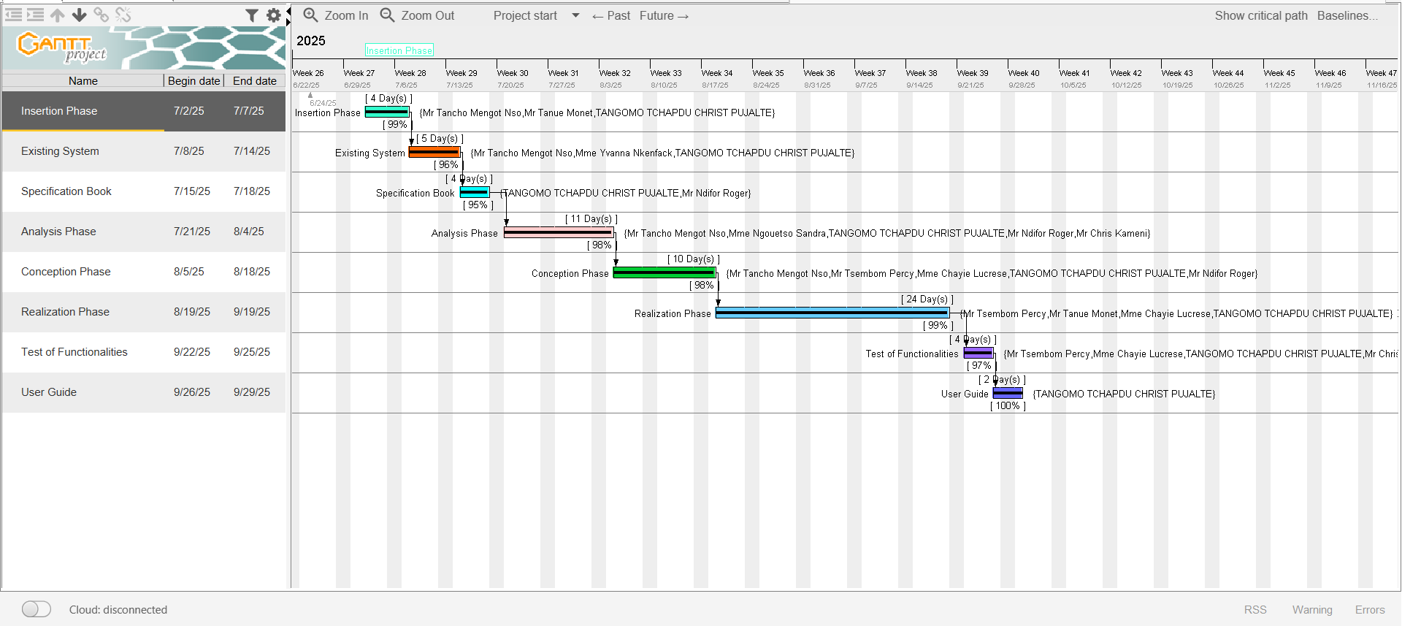
Figure 3: Gantt Project

PROJECT COST

Software Resources
Table 5: Software Resources (source: Mercurial-2025)
RESOURCES | DESIGNATION | USAGE | QUANTITY | UNIT COST (FCFA)
Operating System | WINDOWS 10 PRO 64 bits | Computer Operating System | 1 | 126 000
Formatting | MICROSOFT OFFICE PROFESSIONAL | Writing of the report | 1 | 355 465
Web Hosting | AWS Cloud | Deploying the backend online | 1 | 150 000
Code Editor | Visual Studio Code | For writing the code of the application | 1 | Freemium
Project Planning | Gannt Project | For building a Gantt chart | 1 | Freemium
UML Analysis | Visual Paradigm | For drawing UML diagrams | 1 | Community Version
Version Control | Git & GitHub | For tracking and managing changes to software code | 1 | Free Version
GEOLOCATION API | Google Maps Api | Path optimization, and real time tracking | 1 | 150 000
TOTAL 1 |  |  | 7 | 781 465

Hardware Resources
Table 6: Hardware Resources (source: Mercurial-2024)
RESOURCES | HARDWARE | QUANTITY | UNIT COST (FCFA)
Computer | HP NOTEBOOK G8 CORE i7 11th Gen, HARD DISK 256 GB SSD, RAM 16GB | 1 | 643 750
External Hard Drive | MAXONE 512GB | 1 | 50 000
Smartphones | Google Pixel 7, iPhone Xr | 2 | 375 352
Network | Internet Connection (StarLink) | 1 | 100 000
TOTAL 2 |  | 4 | 1,169,102

Human Resources
Table 7: Human Resources (source: Mercurial-2024)
ROLE | NUMBER OF DAYS | QUANTITY | COST PER DAY | TOTAL PRICE  (FCFA)
Project Manager | 90 | 01 | 30 000 | 2700 000
Analyst | 14 | 01 | 25 000 | 350 000
UI/UX Designer | 14 | 01 | 20 000 | 280 000
Programmer | 35 | 01 | 15 000 | 525 000
Tester | 3 | 04 | 10 000 | 12 000
TOTAL 3 |  |  |  | 3 867 000

Global Project Estimation
Table 8: Global Estimation of Project
SOFTWARE RESOURCES | 781,465 FCFA
HARDWARE RESOURCES | 1,169,102 FCFA
HUMAN RESOURCES | 3,867,000 FCFA
TOTAL COST | 5,817,567 FCFA
Margin Error (10% of TOTAL COST) | 581 756,7 FCFA
OVERALL PROJECT COST | 6 399 323.7 FCFA
SIX MILLION, THREE HUNDRED AND NINETY NINE THOUSAND THREE HUNDRED AND TWENTY THREE POINT SEVEN FRANCS

PROJECT CONSTRAINTS

Technical Constraint
We possess robust tools that ensure a minimum level of security, extensibility, and excellent scalability for the development of our system. Additionally, adherence to all technical standards during the programming phase will result in improved performance and reduced execution time; choosing development technologies is crucial.

Time Constraint
The project will be completed within a period of 12 weeks (3 months), commencing on the start date of July 01st, 2025.

Cost Constraint
The implementation of our project will necessitate expenses on manpower, materials, and software, amounting to a total of 6 399 323.7 FCFA.

LIST OF PARTICIPANTS AND DELIVERABLES

List of participants
Table 9: List of Participants
NAME | FUNCTION | ROLE
Mrs. CHAYIE LUCRESE | Follows up interns at the company level | Professional Supervisor
Mr. NDIFOR ROGER | Follows up students at the academic level | Academic Supervisor
TANGOMO TCHAPDU CHRIST PUJALTE | 2nd Year at AICS-Cameroon | Project head, Analyst, conception and implementation of project, and testing

Deliverables
In project management, any component materializing the result of a realization service is called a deliverable. In the case of our project, the deliverables are: A report composed of the following documents
- A User Guide
- Software Application
- PowerPoint

FILE 3: ANALYSIS PHASE

Preamble

The primary aim of the analysis phase is to comprehend the user's requirements, define the scope of study, and gain a thorough understanding of the system under examination. To accomplish this goal, we will employ the Unified Modelling Language (UML) with the 2 Track Unified Process (2TUP) methodology to analyse the system. Our approach will involve a comparison between UML and MERISE and various other unified processes. Lastly, we will introduce a solution model for our proposed software

Content
INTRODUCTION
I. METHODOLOGY
a) COMPARATIVE STUDIES BETWEEN MERISE AND UML
b) PRESENTATION OF THE 2TUP
c) CHARACTERISTICS OF 2TUP
d) JUSTIFICATION OF THE CHOICE OF THE ANALYSIS
II. MODELING OF THE PROPOSED SOLUTION
a) USE CASE DIAGRAM
b) COMMUNICATION DIAGRAM
c) SEQUENCE DIAGRAM
d) ACTIVITY DIAGRAM
CONCLUSION

INTRODUCTION
System development can be thought of as having two major components: System analysis and system design, which both help in understanding the details of the existing system or the system to be designed. The analysis and design of information systems has the vocation to allow the creation of databases, which must represent as closely as possible the reality of the field studied, thus requiring the use of a design method. This is why our choice will be directed to the UML method as it offers much to developers seeking a user-centred approach and/or a wide scope in design. This part of the report consists of the comparative study of UML and MERISE, unified processes, and finally, the various diagrams that meet the functional need requirements.

METHODOLOGY

COMPARATIVE STUDY OF UML AND MERISE

MERISE
MERISE stands for “Méthode d’Étude et de Réalisation Informatique pour des Systèmes d’Entreprise”. Although it is prescriptive to some extent, MERISE permits the participation of end users and senior management as well as data processing professionals in its decision cycle. MERISE is a method for designing, developing, and carrying out IT projects. The goal of this method is to achieve the design of an information system. The MERISE method is based on the separation of data and processing to be carried out in several conceptual and physical models. The essentials of the approach lie in its three cycles: the decision cycle, the life cycle, and the abstraction cycle, which cover data and process elements equally. The separation of data and processing ensures longevity in the model. Indeed, the arrangement of data does not have to be often overhauled, while treatments are more frequently.

UML
UML (Unified Modelling Language) is a standard notation for the modelling of real-world objects as a first step in developing an object-oriented design methodology. Its notation is derived from and unifies the notations of three object-oriented design and analysis methodologies: Grady Brooch's methodology for describing a set of objects and their relationships, James Rumbaugh's Object-Modelling Technique (OMT), and Ivar Jacobson's approach, which includes a use case methodology. Other ideas also contributed to UML, which was the result of a work effort by Brooch, Rumbaugh, Jacobson, and others to combine their ideas, working under the sponsorship of Rational Software. UML captures information about the static and dynamic view of a system. UML 2.0 comprises 13 diagrams that represent the different views of a system. The 13 diagrams can be subdivided into two: Static or structural diagrams and Dynamic diagrams. These diagrams include;

STATIC OR STRUCTURAL DIAGRAMS
- Class diagram
- Object diagram
- Component diagram

- Deployment diagram
- Package diagram
- Profile diagram

BEHAVIORAL DYNAMIC DIAGRAMS
- Use case diagram
- Activity diagram
- State machine diagram
- Sequence diagram
- Communication diagram
- Global Interaction diagram
- Timing diagram

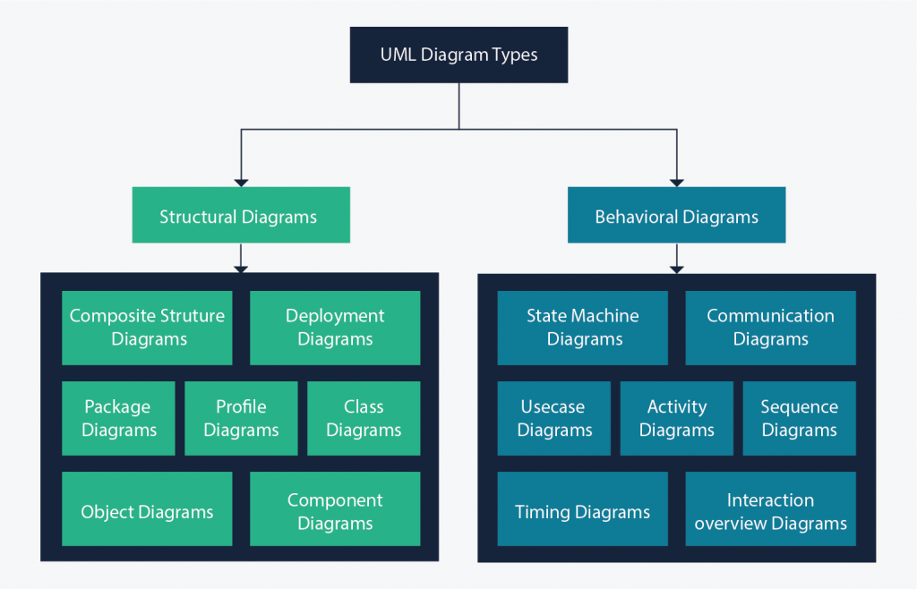
Figure 4: UML 2.5 diagrams overview (source: https://creately.com/blog/diagrams/uml-diagram-types-examples/)
Figure 5: UML 2.5 diagrams overview (source: https://creately.com/blog/diagrams/uml-diagram-types-examples/ )

A very important notice is that UML is not a method but a modelling language. As such, to give it an approach, we need to associate UML to a Unified Process (UP) in other to give our conception a methodology to follow. There exist several Unified Processes, but our modelling approach will be the 2TUP (Two-track unified process), which we will use in the course of our project.

Table 10: Comparison Between MERISE and UML
MERISE | UML
MERISE is a systematic method of analysis and design of information systems. That is, it uses a system approach | UML is, however, not a method but rather an object modelling language to which it is necessary to associate an approach to make it a method. This is the case with the 2TUP method: RUT and XP.
Emphasizes data analysis and modelling using data flow diagrams (DFD), entity-relationship diagrams (ERD), and data dictionaries | Emphasizes system behaviour and structure using 14 diagram types, such as use case diagrams, class diagrams, and activity diagrams
Suitable for relational database design and implementation | Suitable for object-oriented design and implementation

PRESENTATION OF THE 2TUP

Unified Process (UP)
A Unified Process is a process of development of software constructed on UML; it is iterative, incremental, centered on architecture, driven by use cases and requirements.
Iteration is a distinct sequence of activities with a basic plan and evaluation criterion that produces an internal or external output. Either the content of an iteration is improved, or the evolution of the system is evaluated by users.
An increment is the difference between two released products at the end of two iterations. Each iteration, the group is capable of integrating the technical environment in order to develop a final product and give users the possibility of having tangible results.
Centered on architecture, the different models derived during the establishment of system must be reliable and coherent.
Driven by use case and requirements enables the clear definition of a users’ needs and priorities, respectively thereby minimizing the risk of project failure.

Two Track Unified Process (2TUP)
2TUP is a unified process that is built on UML and has as objective to bring solutions to constraints of functional and technical changes imposed on information systems by strengthening controls on development capacities. It proposes a Y-shaped development life cycle that separates the functional aspect from the technical aspects, and the merging of these two forms the implementation aspect. 2TUP distinguishes, therefore two branches: the functional and technical branches. The combination of the results of these two branches forms the third: the realization branch – where we realize our system. The diagram below illustrates the branches of 2TUP.
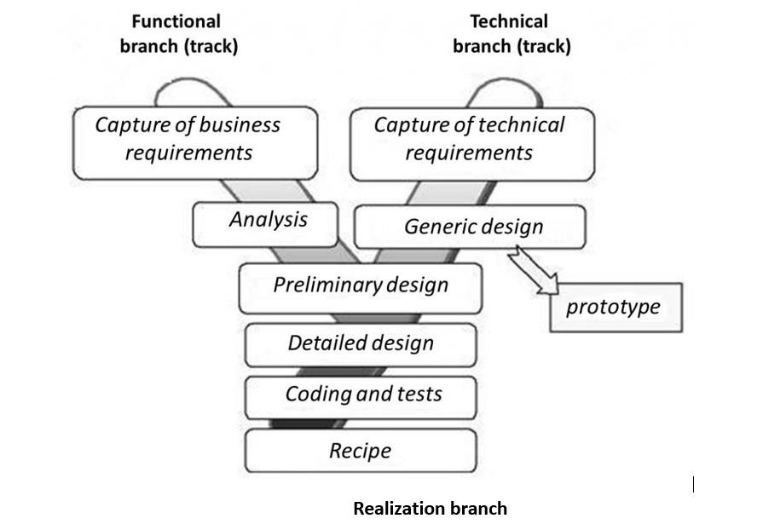
Figure 6: Two Track Unified Process (source: https://www.mysciencework.com/omniscience/pervasive-mobile-healthcare-system-basedon-cloud-computing)

The Left Branch (Functional Branch)
It captures the functional needs of a system. This ensures the production of software that meets the needs/requirements of the user. The analysis here consists of studying precisely the functional specification in order to obtain an idea of what the system is going to realize, and its result does not depend on any technology

The Right Branch (Technical Branch)
The technical branch enumerates the technical needs and proposes a generic design validated by a prototype. The technical needs include constraints and choices related to the conception of the system, the tools and equipment as well as the integration constraint with the existing system condition.

The Middle Branch (Realization or Implementation Branch)
In this branch, we study the preliminary conception, detailed conception, and documentation of the system. The realization branch supports the following:
- Preliminary conception: This is the most sensitive step of 2TUP as it is the confluence of the functional and technical branches. It is completed when the deployment model, the operating model, the logical model, the interfaces, and the software configuration model are defined. We have the following diagrams:
  - Component Diagram
  - Deployment Diagram
  - Package Diagram
  - Composite Structure Diagram
- Detailed conception: This is the detailed design of each feature of the system. We have the following diagrams:
  - Class diagram
  - Object diagram
  - Sequence diagram
  - Timing Diagram
- Coding and testing: This are the phase where we program the designed features and test the coded features.
- The recipe: also known as the deliverables, is the validation phase of the functions of the developed system.

CHARACTERISTICS OF THE 2TUP
The two-track unified process was built to be used with the Unified Modeling Language to become a method and has the following characteristics:
- It is user-oriented: 2TUP is built from users’ expectations.
- It is component-oriented: it offers flexibility to the model by supporting the re-use of components.
- It is an iterative process: processes are being done in iterations, and each iteration shows a precise level of abstraction.
- It is an incremental process: allowing a better functional and technical risk management and thus constituting the deadlines and the cost control.

JUSTIFICATION OF THE CHOICE OF THE ANALYSIS
The reason why we chose UML modelling language and the software development process 2TUP instead of many others that exist includes:
- UML is the current standard for programming in an object-oriented language. For this reason, it is widely understood and well known, making it easy for a new programmer to join the project and be productive from the very first day.
- UML diagrams allow teams to visualize how a project is or will be working, and they can be used in any field, not just software engineering. The diagrams will allow teams to virtualize together how a system, or a process, will work or did work. It can provide new ideas for how teams have to collaborate to achieve the goal of the workflow process.
- 2TUP is centered around the creation and maintenance of a model, rather than the production of mountain documents.
- 2TUP is user-oriented as it permits the development of software that responds to the needs of the users through the study of the user needs.
- 2TUP is iterative and incremental, hence it enables the project team to produce refined amelioration if necessary and easily integrate it into the already existing system.
- 2TUP by permitting the project team to identify and test the key functionalities of the system limits the risk related to building the system.

MODELLING OF THE PROPOSED SOLUTION
The first step of the left (functional) branch of Two Track Unified Process (2TUP) is the capture of the functional needs. At this step, we capture the intended behavior of the system that may be expressed as services, tasks, or functions the system is required to perform.

USE CASE DIAGRAM
- Definition
A use case diagram shows the functionalities of a system, their interdependencies, and how they relate to the actors of the system. A use case is a specification of behavior. The main objectives of the use case diagram are:
- Provide a high-level view of the system.
- Identify the functions of the system.
Use case diagrams are completed with a textual description of each use case that is intended to define the use case in greater detail.

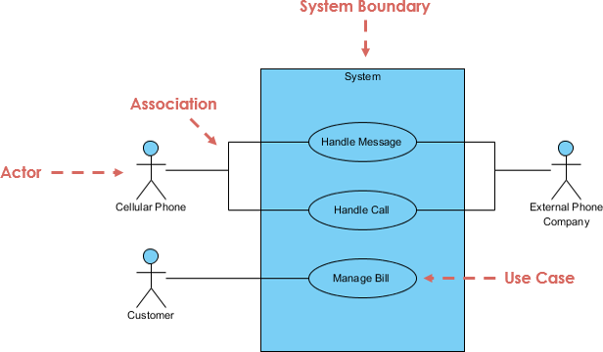
Formalism
Figure 7: Use Case Formalism

Components of Use case Diagram
Table 11: Components of a Use case Diagram
Element | Notation | Description
Actors |  | Represents an entity that directly interacts with the system. The actor is what performs the different possible actions of the system
Use case | 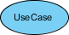 | A use case represents a functionality of the system. It is an action that can be performed by an actor.
Association | 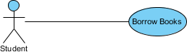 | it indicates that an actor takes part in a use Case
Include |  | An inclusion denotes that an included action must be performed before the including action can be performed.
Extend | 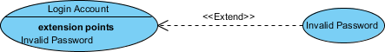 | An extension denotes that an extending action may be performed while an extended action is being performed.
Generalization |  | This shows that an actor or a use case is a kind of another abstract or concrete actors which can be defined and later specialized using generalization relationship.
System |  | It is a container of use cases which interact with external actors

Actors of our system

Primary Actors
Table 12: Primary Actors of Our System
Actor | Role
Client | A client is the primary user of the app who requires Food delivery services. They can browse different restaurants, place an order, track the Order, and chat with a Delivery agent.  They also have the possibility to rate delivery agents and restaurants at the end of every order
Delivery agent | A delivery agent is responsible for handling the delivery of orders form a particular partner to the client who placed the order. He is able to update his availability status. Such that if offline the system cannot assign him orders.
Partner | Partners represent individuals or businesses providing restauration services. Partners can receive orders from clients, manage their profiles, and manage their menus.
Admin | The admin is responsible for overseeing the platform's operations, ensuring everything functions smoothly. They manage users (client, Partners), handle approvals for new partners, delivery agents, handles Feedback from users, and monitor the system's activities.

Secondary Actors
Table 13: Secondary Actors of our system
Actors | Role
Geolocation API | The Geolocation API provides real-time location data, allowing the app to offer services like tracking the delivery agent’s position during the order tracking process.
Payment API | The Payment API facilitates secure and efficient financial transactions within the app. It handles the processing of payments from customers for Order placing

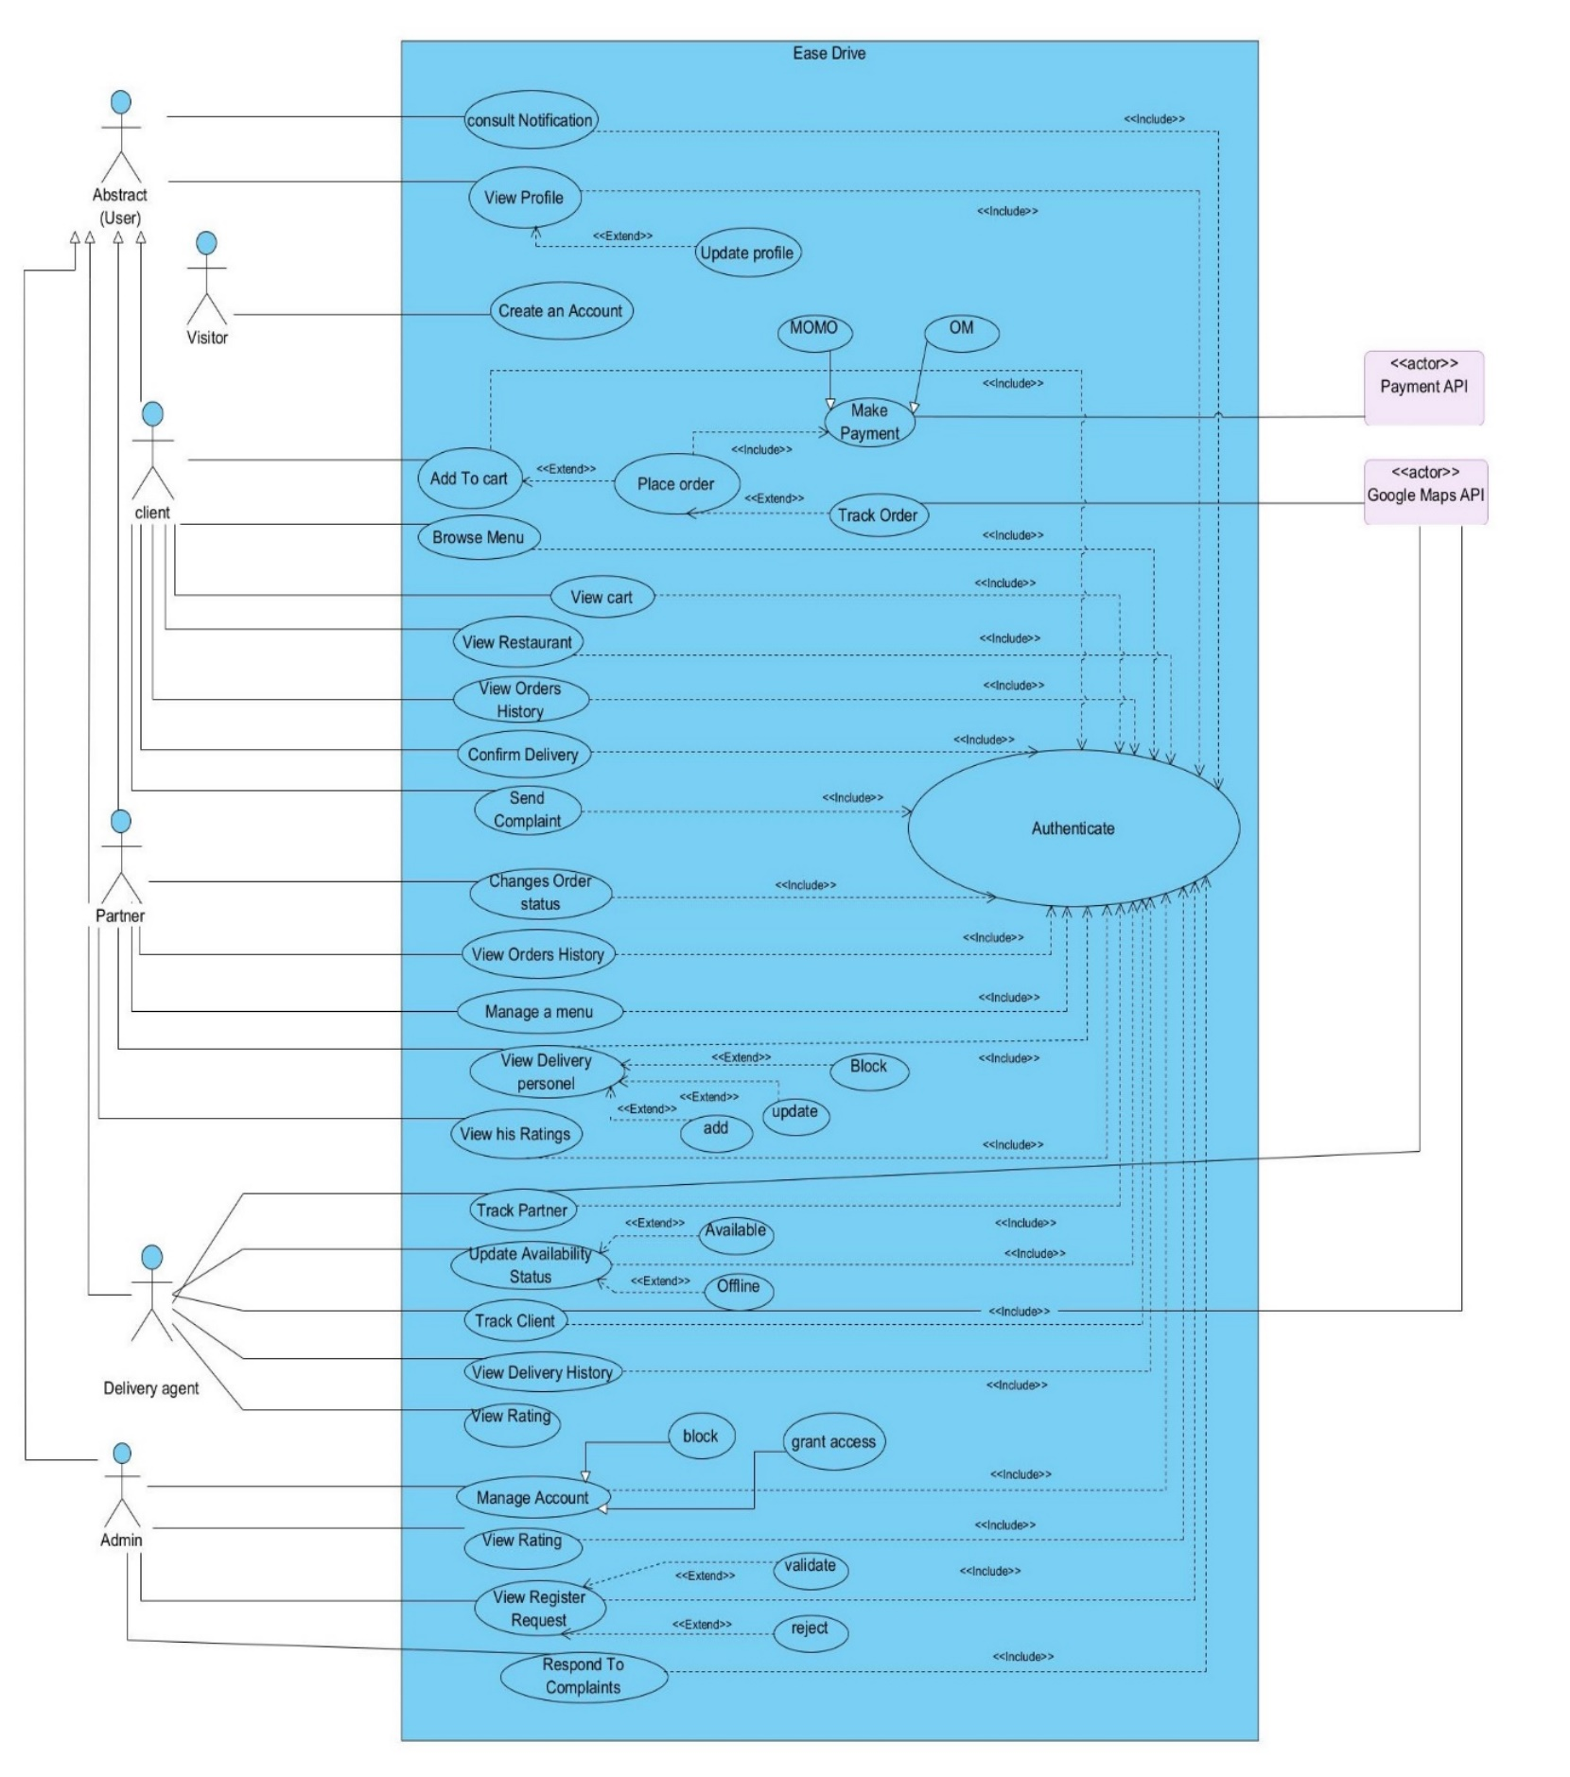
EaseDrive Use case diagram
Figure 8: General Use case Diagram

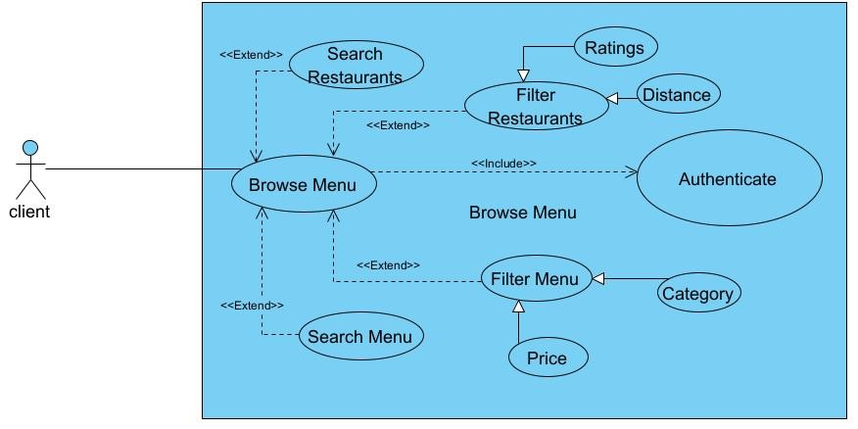
Browse menu Specific Use Case
Figure 9: Browse menu Specific Use case

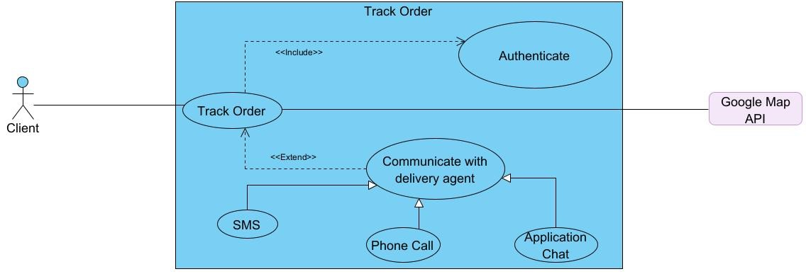
Track Order Specific Use Case Diagram
Figure 10: Track Order Specific UseCase

TEXTUAL DESCRIPTION OF SOME USE CASES
UML allows the execution of a use case to be described in a textual way, in a form called a nominal scenario. A nominal scenario describes in more detail the execution of a use case by an actor until it is successfully completed.

Formalism
A textual description of a use case is represented in the following form.

Table 13: Textual Description Formalism
NAME OF THE USE CASE
Summary | Aim of the use case
Actors | Users
Pre-condition | A set of actions that must be completed before the launching of the use case
Trigger | The event that causes the use case to be initiated
Nominal scenario | It corresponds to a normal development of a use case
Alternative scenario | These are variants of the nominal scenario.
Post condition | A set of mechanisms that can lead to the end of the use case

- Authenticate
USE CASE AUTHENTICATE
Summary | Permit the client to access the system
Actors | Client, Technician , Admin
Date | September 25, 2026
Stake Holders | TechFinder directors
Version | 1.0
Pre-condition(s) | - The actor already has an account.  - The account must be active
Trigger | The User clicks login button
Nominal scenario | - The user launches the app  - The system displays the login page  - The user fills form and submits  - The system checks conformity  - The system sends a validation query  - The system treats the result returned by the database  - The user is directed to his page
Alternative scenario | - If step 4 of the nominal scenario, the format is not correct, an error message is returned to the user, and he returns to step 3 of the nominal scenario.  - If step 6 of the nominal scenario, no user was found, the system returns an error message and returns to step 2 of the nominal scenario
Post-condition of success | The user logs in successfully
Post condition of failure | An error message is displayed, and the user does not have access to their space.
Table 14: Textual description of Authenticate

- Create Account (Client)
USE CASE CREATE ACCOUNT
Summary | Grant’s users access to the application
Actors | Client
Date | September 20, 2025
Stake Holders | EaseDrive directors
Version | 1.0
Pre-condition(s) | - The App is launched
Trigger | The User clicks on the Get Started button
Nominal scenario | - The user launches the app  - The system displays the login page  - The user clicks on the Signup Button  - The system displays the registration page  - The user fills form and submits  - The system checks conformity  - The system sends a validation query  - The system treats the result returned by the database  - The user is directed to his page
Alternative scenario | - If step 6 of the nominal scenario, the format is not correct, an error message is returned to the user, and he returns to step 4 of the nominal scenario.  - If step 8 of the nominal scenario, no user was found, the system returns an error message and returns to step 4 of the nominal scenario
Post-condition of success | The user’s account is created
Post condition of failure | An error message is displayed
Table 15: Textual description of Create Account(client)

- Create Account (Delivery Agents, Partner)
USE CASE CREATE ACCOUNT
Summary | Grant’s users access to the application
Actors | Delivery Agent, Partner
Date | September 20, 2025
Stake Holders | EaseDrive directors
Version | 1.0
Pre-condition(s) | - The App is launched
Trigger | The User clicks on Get Started button
Nominal scenario | - The user launches the app  - The user clicks on Get Started button  - The system displays the login page  - The user clicks on Signup Button  - The system displays the client registration page  - The User clicks on button Partner with Us  - The user selects his Role  - The system displays the Corresponding Registration page  - The user fills form and submit  - The system checks conformity  - The system sends validation query  - The system treats the result returned by the database  - The user is directed to his page
Alternative scenario | - If step 9 of the nominal scenario, the format is not correct, an error message is returned to the user, and he returns to step 7 of the nominal scenario.  - If step 11 of the nominal scenario, no user was found, the system returns an error message and returns to step 7 of the nominal scenario.
Post-condition of success | The user’s account is created
Post condition of failure | An error message is displayed
Table 16: Textual description of Create Account (Delivery Agent and Partner)

- Place Order
USE CASE PLACE ORDER
Summary | Grant’s users access to the application
Actors | Client
Date | September 20, 2025
Stake Holders | EaseDrive directors
Version | 1.0
Pre-condition(s) | - The app is launched  - The user is authenticated  - The user added menu to carts
Trigger | The User clicks on Place Order button
Nominal scenario | - The user clicks on place order button  - The system displays a delivery information form  - The user fills and submit the form  - The system checks, delivery agents available and assign the Order.  - The system displays a payment form to client  - The User fills and submit the payment form  - The system checks form conformity  - The system sends a payment query to payment api  - The system treats the response from payment Api  - The system send a save query to Database  - The system treats returned result by database  - The system displays successful message.
Alternative scenario | - If step 9 of the nominal scenario, the format is not correct, an error message is returned to the user and he returns to step 7 of the nominal scenario.  - If step 11 of the nominal scenario no user was found, the system returns an error message and returns to step 7 of the nominal scenario
Post-condition of success | An Order is created, and a notification is sent to Partner and delivery Agent to whom the system assigned the Order
Post condition of failure | An error message is displayed
Table 17: Textual decsription Place Order

COMMUNICATION DIAGRAM

Definition
Communication Diagrams model the interactions between objects in a sequence. They describe both the static structure and the dynamic behavior of a system. It is a simplified version of a Collaboration Diagram introduced in UML 2.0. A communication diagram is more focused on showing the collaboration of objects rather than the time sequence.

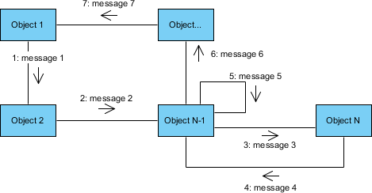
Formalism
Figure 11: Communication diagram formalism

Components of a Communication Diagram
Table 18: Components of a communication diagram
Element | Notation | Description
Message | 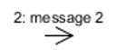 | Designs a particular communication between lifelines.
Actors |  | A role plays by an entity that interacts with the subjects
Link |  | It initiates an association it connects two objects together for them to communicate.
Object | 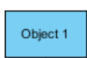 | An actor represents an individual participant in the interaction conversation

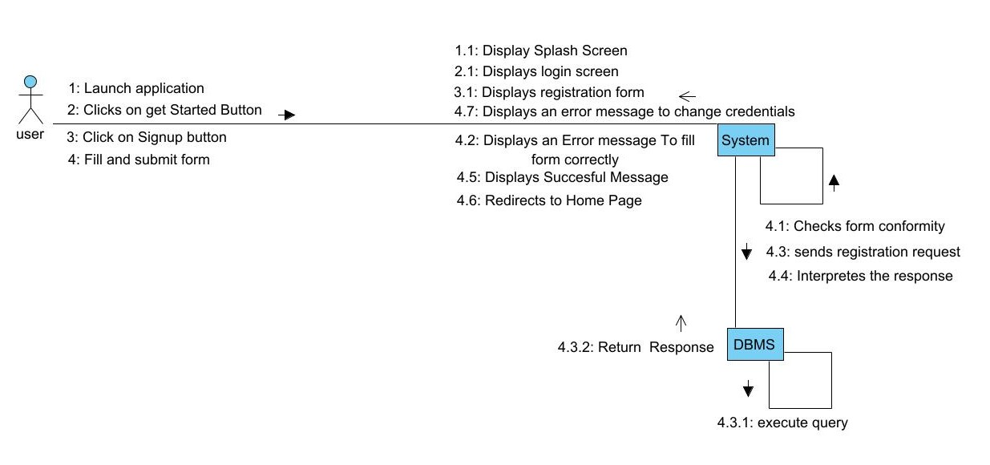
Communication diagram of Create account
Figure 12: Communication diagram of Create Account

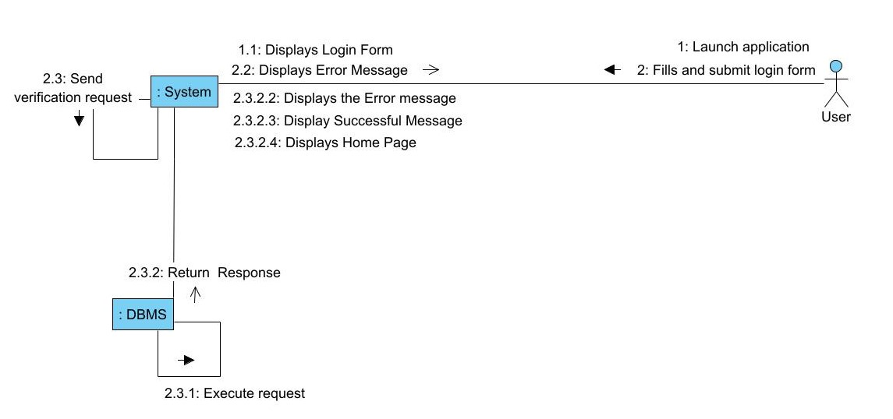
Communication diagram of Authenticate
Figure 13: Communication diagram of Authenticate

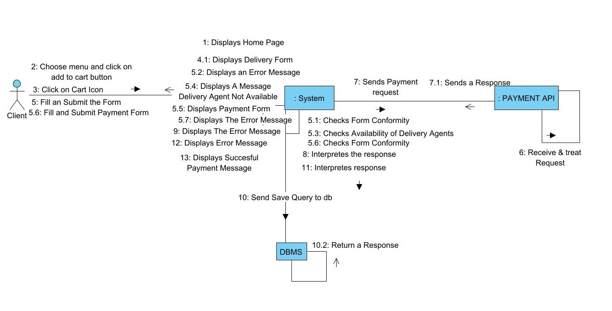
Communication diagram of Place Order
Figure 14: Communication diagram of Place Order

SEQUENCE DIAGRAM

Definition
A Sequence diagram describes interactions among classes in terms of an exchange of messages over time. They are also called event diagrams. A Sequence diagram is a good way to visualize and validate various runtime scenarios. These can help to predict how a system will behave and to discover responsibilities a class may need to have in the process of modelling a new system.

Formalism
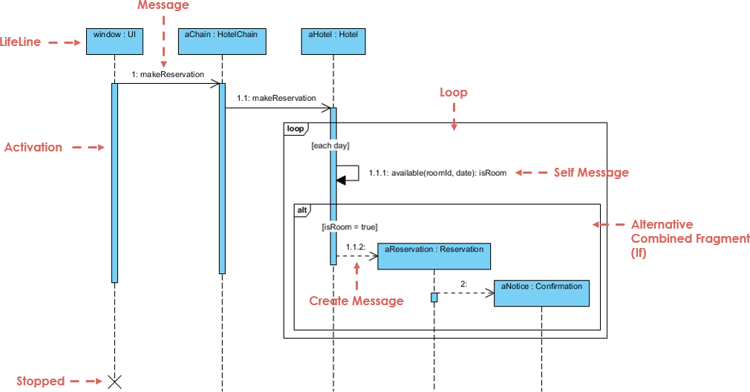
Figure 15: Sequence diagram Formalism

Components of a sequence diagram
Table 19: Components of a Sequence diagram
Element | Notation | Description
Lifelines | 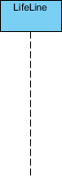 | They represent rows or objects instances that participate in the sequence being modelled.
Asynchronous Message | 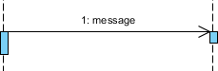 | It is a message that receives an indirect response.
Synchronous Message |  | It is a message that sends and want a response before it continues a process
Self-Message | 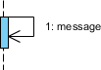 | Self-message is a kind of message that represents the invocation of message of the same lifeline.
Return Message | 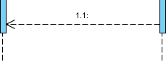 | It represents the response of a message.
Actor |  | They send and receive message.
Combined Interaction Fragment | 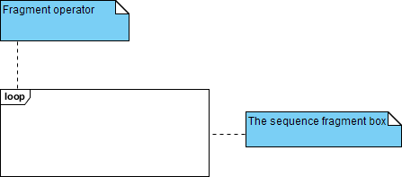 | An articulation of interaction diagram, defined by an operator and operands.
Object |  | They send and receive messages

Sequence diagram of authentication
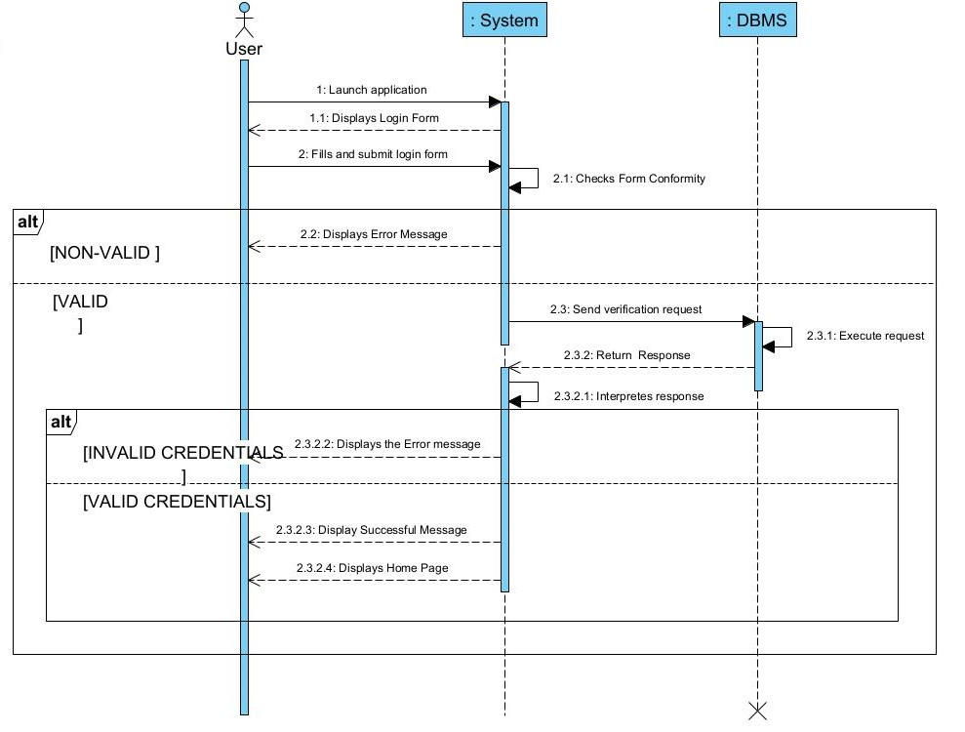
Figure 16: Sequence diagram of Authenticate

Sequence diagram of create account
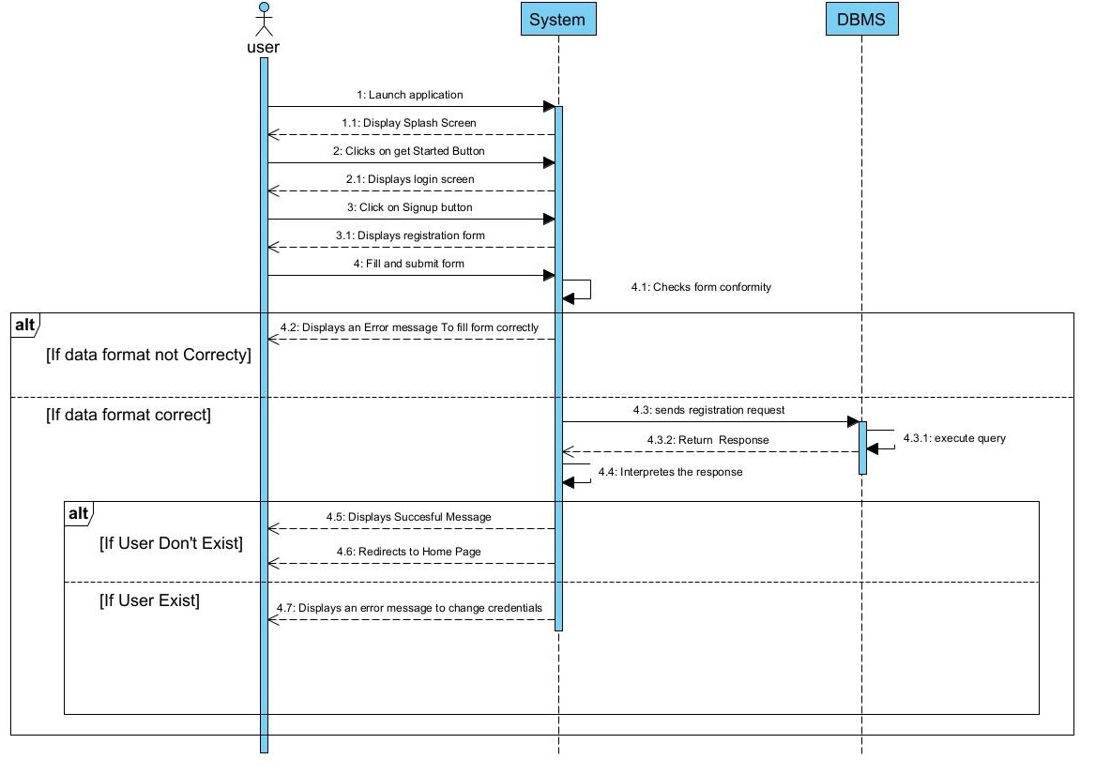
Figure 17: Sequence diagram of Create Account

Sequence diagram of Place order

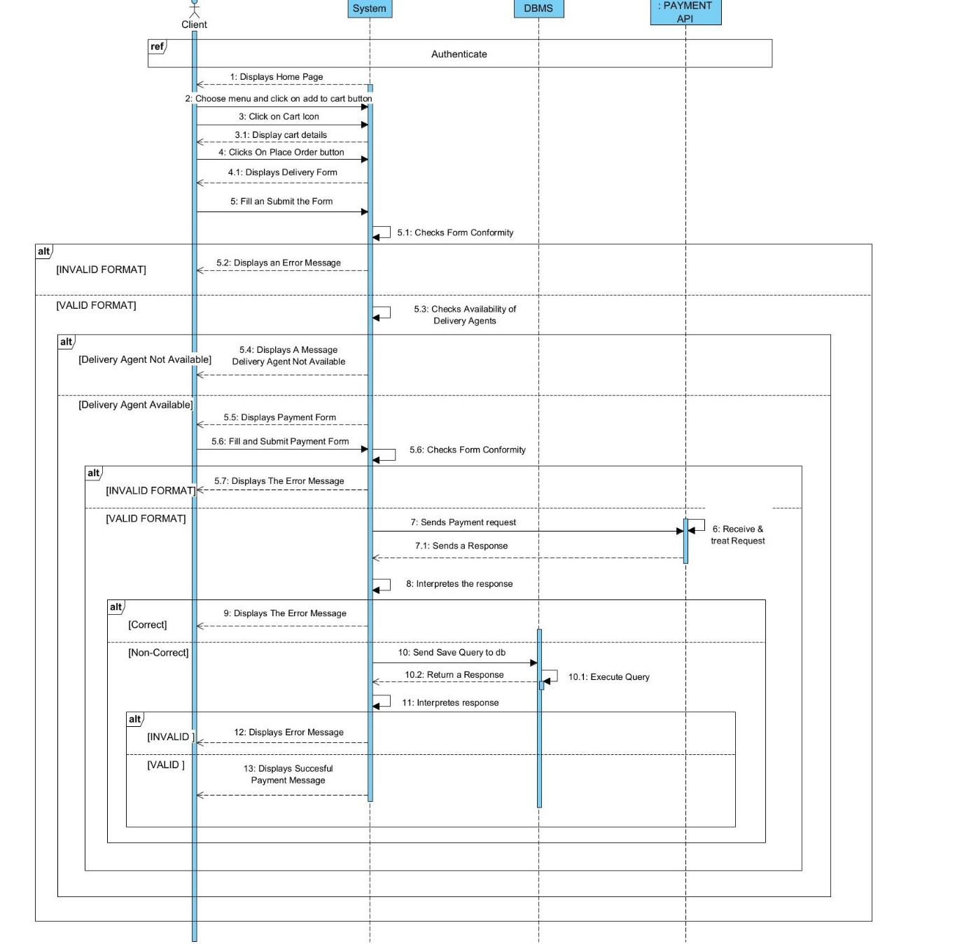
Figure 18: Sequence diagram of Place Order

ACTIVITY DIAGRAM

Definition
An activity diagram is a graphical representation of workflows that show the steps needed in the realization of a process, showing the details from a start point to an end point through all decisions and actions that can possibly be performed. Activity diagrams are intended to model both the computational and organisational process. The flow can be sequential, branched or concurrent. Below is an activity diagram formalism.

Formalism
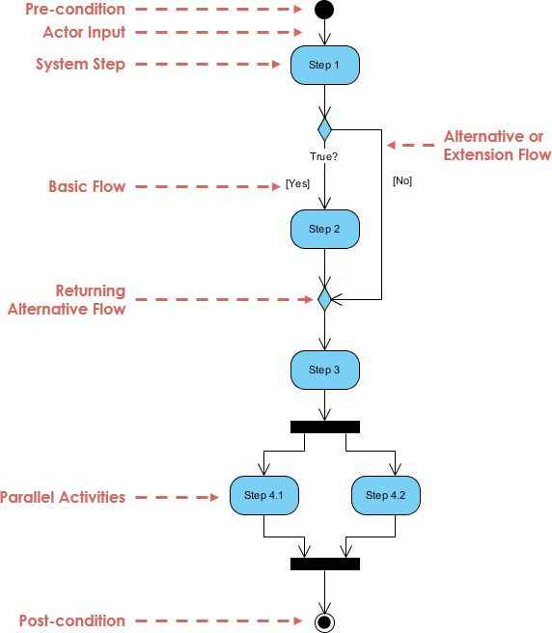

Figure 19: Activity Diagram Formalism

Component of an Activity Diagram
Table 20: Components of an Activity diagram
Element | Notation | Description
Activity | 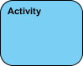 | Is used to represent a set of actions
Action |  | A task to be performed
Activity Edge |  | An activity edge in a UML activity diagram is a directed connection between two activity nodes. It represents the flow of control or data between these nodes.
Initial node |  | Portrays the beginning of a set of actions or activities
Activity Final Node |  | Stop all control flows and object flows in an activity (or action)
Object node | 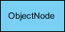 | Represent an object that is connected to a set of Object Flows
Decision node | 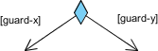 | Represent a test condition to ensure that the control flow or object flow only goes down one path
Merge node |  | Bring back together different decision paths that were created using a decision-node.
Fork node | 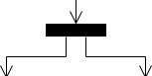 | Split behaviour into a set of parallel or concurrent flows of activities (or actions)
Join node |  | Bring back together a set of parallel or concurrent flows of activities (or actions).
Swimlane and Partition | 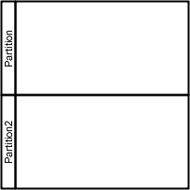 | A way to group activities performed by the same actor on an activity diagram or to group activities in a single thread

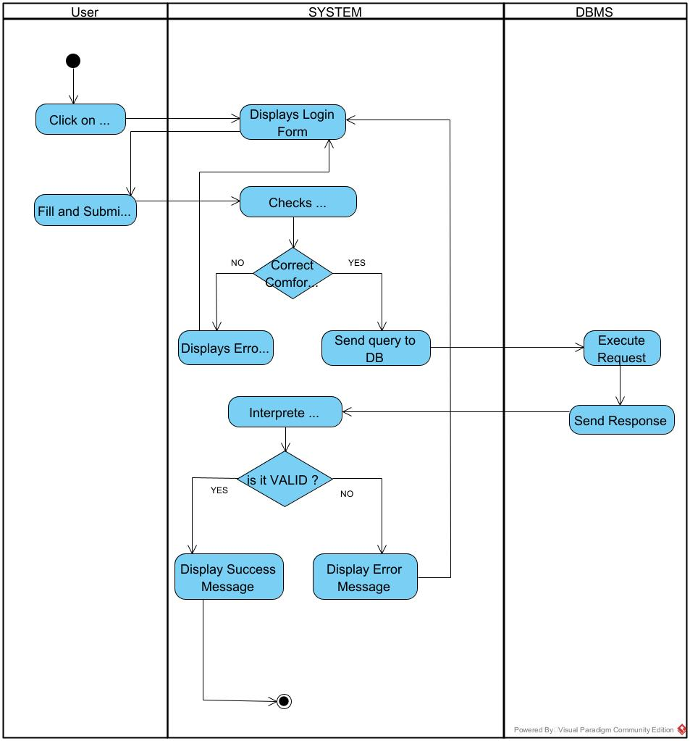
Activity Diagram of Authenticate

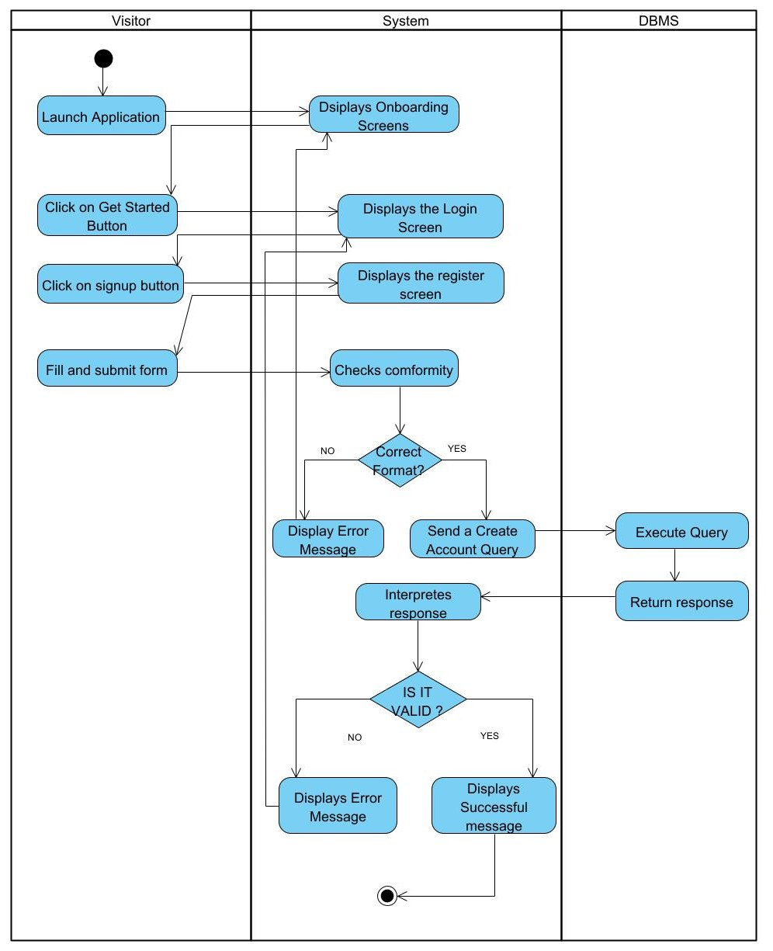
Activity Diagram of Create Account
Figure 21:Create Account Activity diagram

Place Order Activity Diagram
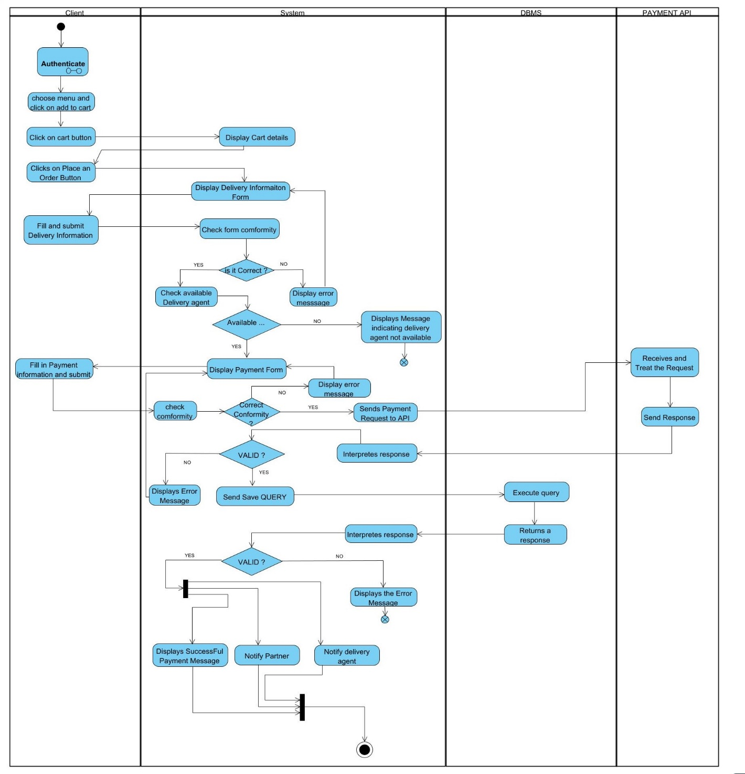
Figure 22: Place Order Activity diagram

FILE 4 : CONCEPTION PHASE

Preamble

This document makes it possible to model the proposed solution as a whole and to gather the information necessary to set up a complex and efficient database. It therefore foresees the future system.

Content
INTRODUCTION
- CAPTURE OF TECHNICAL NEEDS
- CLASS DIAGRAM
- STATE MACHINE DIAGRAM
- PACKAGE DIAGRAM
CONCLUSION

INTRODUCTION
The realization of an analysis file is very important for the advancement of the application, as it guarantees the reliability of maintenance and use of the software. That said, after analyzing our system, we will move on to the design of our future system. To do this, we will follow the steps of the technical branch of the 2TUP process, making the diagrams associated with these steps, namely the class diagram and the state machine diagram.

CAPTURE OF TECHNICAL NEEDS

PHYSICAL ARCHITECTURE
When designing an application, it is important, before going any further to know the architecture of this application. The choice of your architecture can be based on: the number of users, the data volume, transaction volume, performance requirements, and security needs.
Within the scope of our project, we made use of the n-tier architecture. This is because we are making use of external APIs, in our case, the payment API and Google Maps API. Our system is made up of:
- The presentation layer
- The business layers
- The External API layer
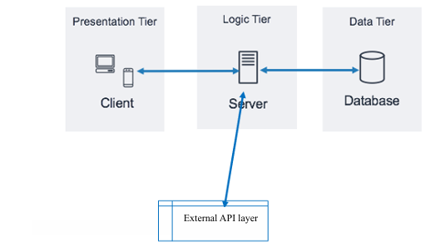
- The database layer.
Figure 23: Physical Architecture diagram

LOGICAL ARCHITECTURE
Model View Controller, commonly referred to as MVC, is a software design pattern used for building applications. This pattern consists of three main components: the model, the view, and the controller.
- Model: The lowest level of the pattern, which is responsible for maintaining the data.
- View: This is responsible for displaying all or a portion of the data to the user.
- Controller: It handles software code that controls the interactions between the model and the view.
MVC is popular as it isolates the application logic from the user interface and supports the separation of concerns. Here, the controller receives all requests for the application and then works with the model to prepare data needed by the view. The view then uses the data prepared by the controller to produce a final response. The MVC can be represented as follows:
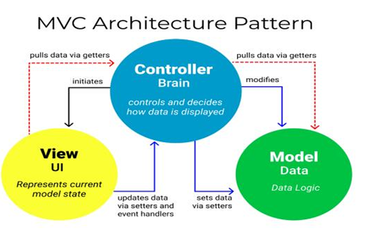
Figure 24: Logical Architecture

CLASS DIAGRAM

Definition
A class diagram is a static diagram. It represents the static view of an application. class diagrams are not only used for visualizing, describing, and documenting different aspects of the system, but also for constructing executable code of the software application. A class diagram describes the attributes and operations of a class and constraints imposed on the system. Its purpose is to model the static view of an application.

Formalism
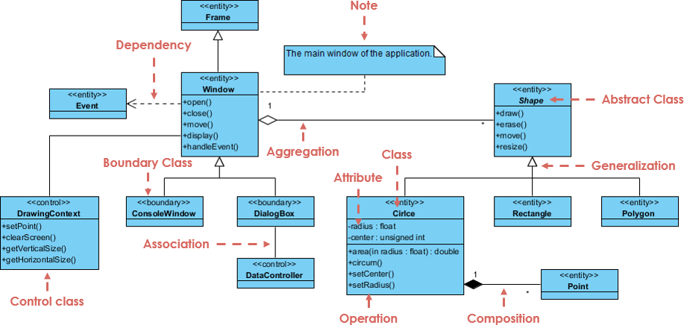
Figure 25: Class diagram formalism

Components of a Class Diagram
Table 21: Components of a class diagram
Element | Notation | Description
Class | 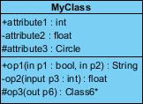 | A class is an element that defines the attributes and behaviors that an object can generate
Generalization | 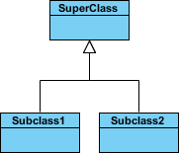 | it a relationship between a whole thing (called superclass) and a more specific thing (called subclass)
Association | 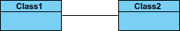 | It is a general type of relationship between elements, it may include cardinality, roles etc.
Aggregation | 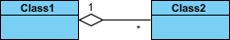 | If the parent of the aggregate is deleted, the children are not deleted.
Composition | 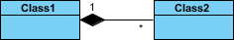 | If a parent of a composite is deleted all its parts are deleted with it.
Dependency | 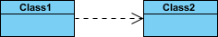 | It existed between two classes, if one changes it may cause the change in the order, but the other way around

EaseDrive Class Diagram
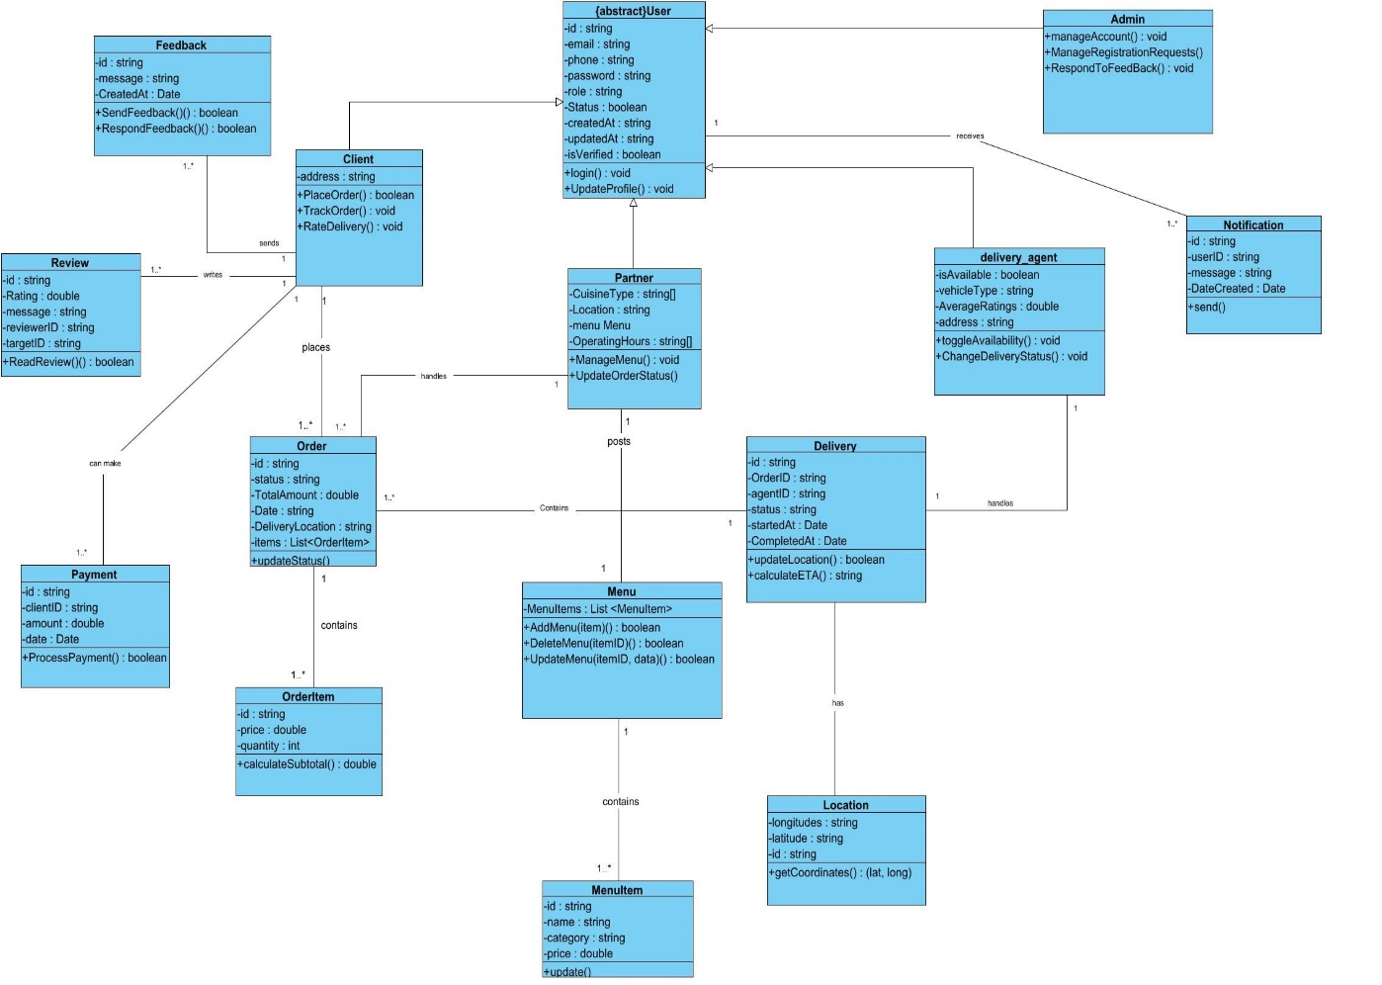
Figure 26: EaseDrive Class daigram

STATE MACHINE DIAGRAM

Definition
State diagrams are used to document the various modes (states) that a class can take, and the events that cause a state transition. Their role is to present the treatments (operations) that will manage the field studied. They define the sequence of class states, also known as the state chart diagram, which models the dynamic flow of control from the state of a particular object within a system.

Formalism
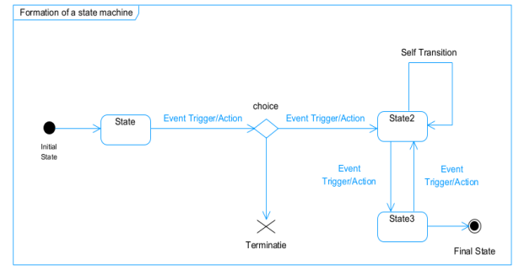
Figure 27: State machine diagram formalism

Components of a State Machine diagram
Table 22: Components of a state machine diagram
Element | Notation | Description
State | 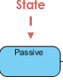 | Models a situation during which a certain invariant condition holds.
First (Initial State) | 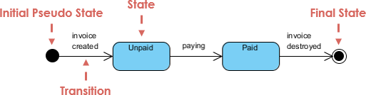 | It represents a default vertex, that is, a source for a single transaction to the default or composite state.
Final state |  | A state specifying that the enclosing region is complete
Transition |  | A direction relation between a source and a target vertex.
Choice pseudo state |  | A diamond symbol that indicates a dynamic condition with branched potential results
Terminate |  | Implies that the execution of a state by means of its context is terminated.
Diagram overview |  | A placeholder for the linked states in a state machine diagram.

Account State machine diagram
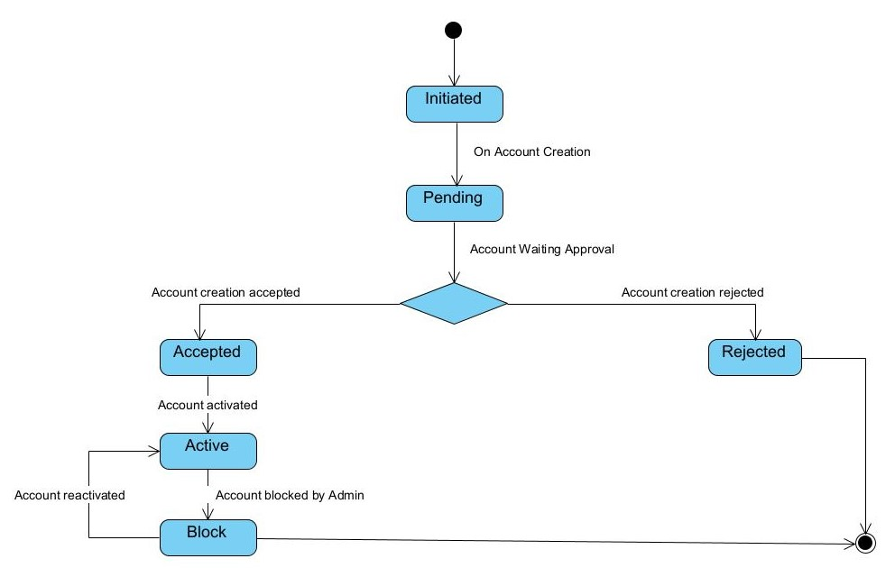
Figure 28: Account state machine diagram

PACKAGE DIAGRAM

Definition
This is a structural diagram used to show the organization and arrangement of various model elements in the form of packages. A package diagram is the grouping of related uml elements such as classes, diagrams or even other packages.

Formalism
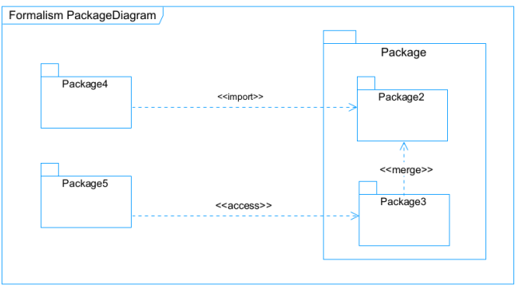
Figure 29: Package diagram formalism

Component of package diagram
Table 23:Component of a package diagram
Element | Notation | Description
Package | 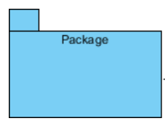 | A package is a namespace use to group related elements; it is a mechanism used to group elements into a better structure in a system.
Package import | 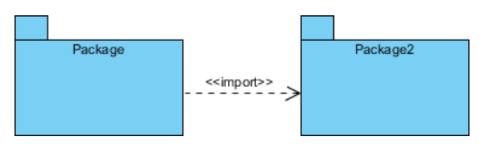 | A relationship Indicate that, functionality has been imported from one package to another.
Package access | 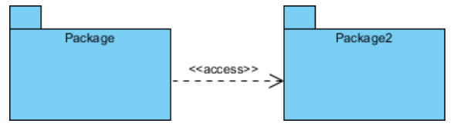 | Arelationship Indicates that one package requires assistance from the function of another package.
Package merge | 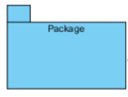  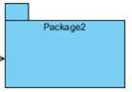   | It is a relationship which shows that, the functionality of two packages are combines to a single function.

EaseDrive Package Diagram

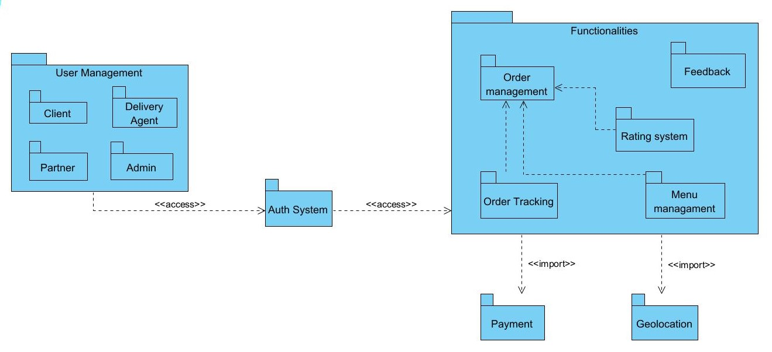
Figure 30: EaseDrive package diagram

CONCLUSION
We presented the structure of our system and its integration into the existing technical architectures. In the initial stage, we aimed to investigate various aspects of our system. Primary actions included assessing the technical limitations, identifying the system's components with their classification and deployment onto relevant deployment targets. We then concluded this phase by evaluating the interactions between different components and participants of our system. Moving forward, our report will now progress to the implementation phase, which will entail concentrating on executing our system-related elements.

FILE 5 : REALIZATION PHASE

Preamble

The realization document consists of the implementation of the project in a programming language according to the specifications defined in the previous file. It contains component and deployment diagrams, as well as the testing and development phases. At the end of this part, programming documentation will be produced explaining the architecture of the database and the architecture of our code.

Content
INTRODUCTION
I. DEPLOYEMENT DIAGRAM
II. COMPONENT DIAGRAM
III. TECHNICAL CHOICES
CONCLUSION

INTRODUCTION
Design and modeling are important links in the development process of an application because they make it possible to define and specify the different elements constituting the application or system studied. Realization is the culmination of the work carried out upstream because it makes it possible to physically create the various objects that were designed, and to bring the computer system to life. Throughout this phase, we will present the software, physical, and hardware architecture of our system through diagrams such as the component diagram, deployment diagram, physical model, and code architecture.

DEPLOYMENT DIAGRAM

Definition
A deployment diagram is a structural diagram used to visualize the topology of the physical components of a system, where the software is deployed. They consist of nodes and their relationship. It is related to the component diagram because the components are deployed using the deployment diagram. A deployment diagram consists of nodes. Nodes are nothing but physical hardware used to deploy the application.

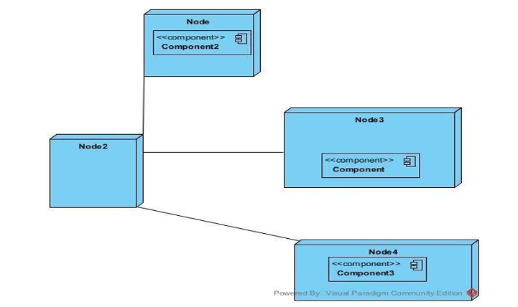
Formalism
Figure 31: Deployment diagram formalism

Components of a deployment diagram
Table 24: Components of a deployment diagram
Elements | Description | Representation
Component | A component represents a software entity of the system. | 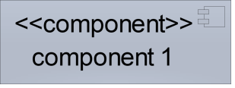
Node | A node represents a set of hardware elements of the system. A three-dimensional cube represents this entity or node. | 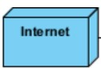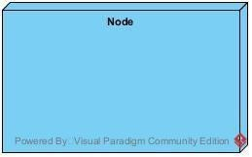
Interface | Represents a declaration of a set of coherent public features and obligations | 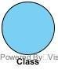
Dependency (manifestation deployment) | A relationship between two model elements where changes in one of them will similarly affect the other | 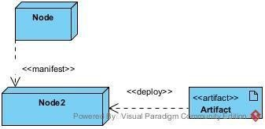
Artifact | An artifact is a major product that is produced or used during the development of software. E.g., diagrams, data models, setup  Scripts. | 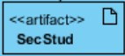

EaseDrive deployment diagram

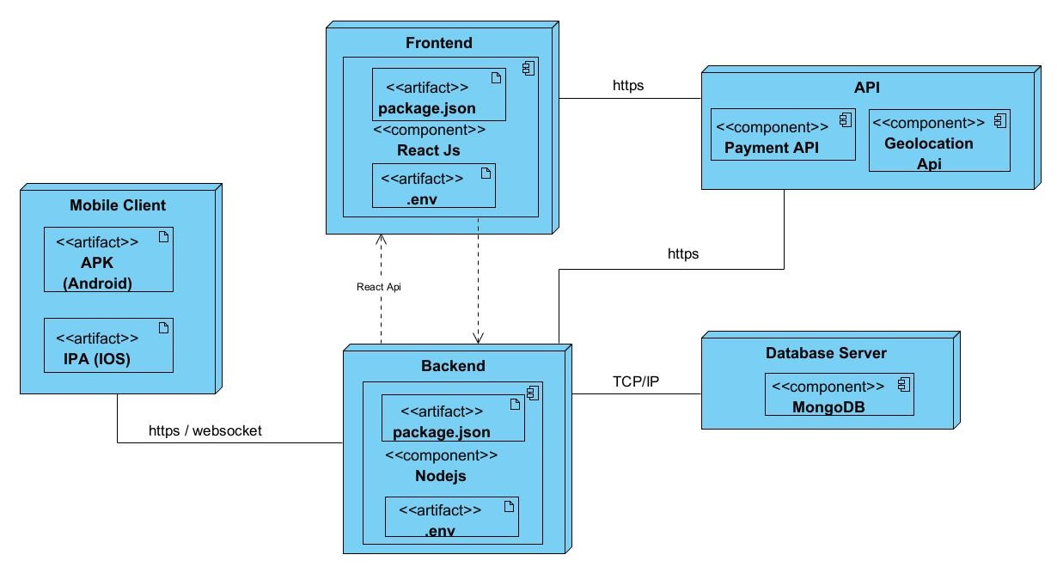
Figure 32: EaseDrive deployment diagram

COMPONENT DIAGRAM

Definition
Component diagrams are used to model the physical aspect of a system. Now the question is, what are these physical aspects? They are elements such as Executables, libraries, files, documents, etc., which reside in a node. The component diagram does not describe the functionality of the system, but it describes the components used to make those functionalities.

Formalism
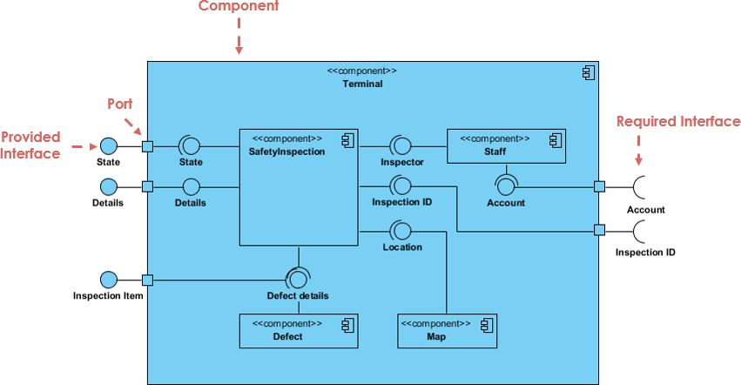
Figure 33: Component diagram formalism

Components of a Component Diagram
Table 25: Components of a component diagram
Element | Notation | Description
Dependency |  | A dependency is a relationship that signifies that a single or a set of model elements requires other model elements for their specification or implementation.
Port |  | A port is often used to help expose required and provided interfaces of a component.
Interface | 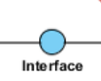 | It is a point of interaction between a component and its environment or other components. It specifies the services that a component provides or requires from other components
Component | 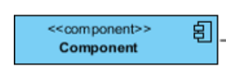 | It represents a self-contained and replaceable unit that interacts with other components via provided and required interfaces

EaseDrive Component Diagram
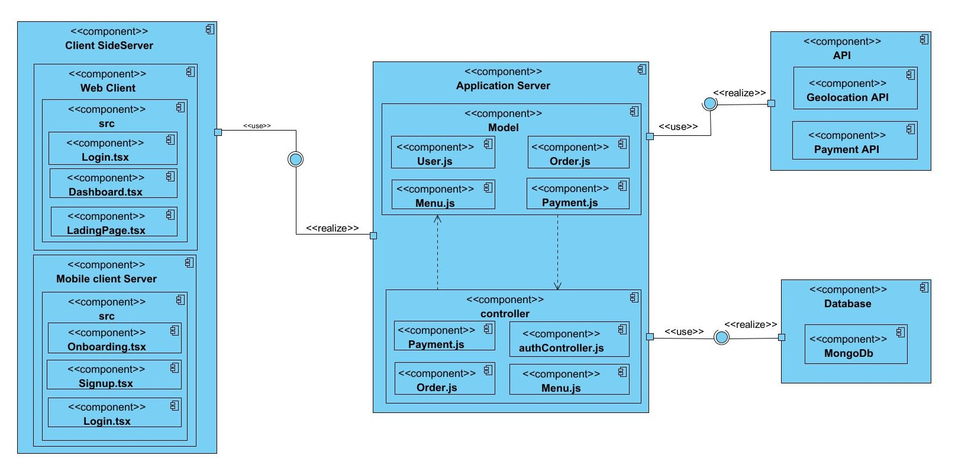
Figure 34: EaseDrive component diagram

CONCLUSION
During our realization phase, we successfully developed and implemented our application. To achieve this, we utilized our analysis and conception phase. We also created deployment and component diagrams, which illustrate the modules, files, and assets, as well as how different elements interact with each other within our system. Our next step is to proceed to the functionality testing phase, where we will assess the efficacy of the various modules present in our app for different users.

FILE 6: FUNCTIONALITY TESTING PHASE

Preamble

This phase aims at testing the software or application to verify if the system is working as expected. It involves testing individual functionalities and capabilities of the software to ensure that they work correctly and meet the specified needs.

Content
INTRODUCTION
I. TESTING FUNCTIONALITIES
II. TESTING SHOWCASES
CONCLUSION

INTRODUCTION
The test of functionalities plays a crucial role in ensuring the quality and reliability of software systems. By thoroughly examining each functionality and validating its behaviour, developers can identify potential issues early in the development process. This helps in reducing the overall cost and effort required for bug fixing and maintenance.

TESTING OF FUNCTIONALITIES

What is Unit Testing
Unit testing involves testing the smallest parts of an application, such as functions or methods, independently of the rest of the application. The primary goal is to validate that each unit of the software performs as expected.

Unit Testing Importance
Unit testing ensures that each component of the application works independently and correctly. It helps catch bugs early in the development process and guarantees that future changes don't break existing functionality.

Testing Strategies
We implemented unit testing to isolate and test individual parts of the app, specifically the API endpoints and backend services. Unit testing provides fast feedback on code quality and behavior.

Testing Tools Used
- Jest: Testing framework used for running unit tests.
- Supertest: For testing API requests.
- Mockingoose: Used in some instances to mock MongoDB models for tests.

Key Functionalities tested

User registration
- Tests ensure that users can successfully register with valid details.
- Handles test cases where invalid inputs or missing fields cause registration failure.

User Authentication
- Tests confirm that users can log in with correct credentials.
- Includes scenarios where login fails due to invalid credentials (e.g., wrong password).

Manage menu
- Tests verify that all Partners can independently manage their menu
- Includes test cases where an error is returned if a user tries to make a duplicate menu.

Place order
- Verifies that each an every client on the platform is able to add to cart then place an order

TESTING SHOWCASES

Passing Unit Testing
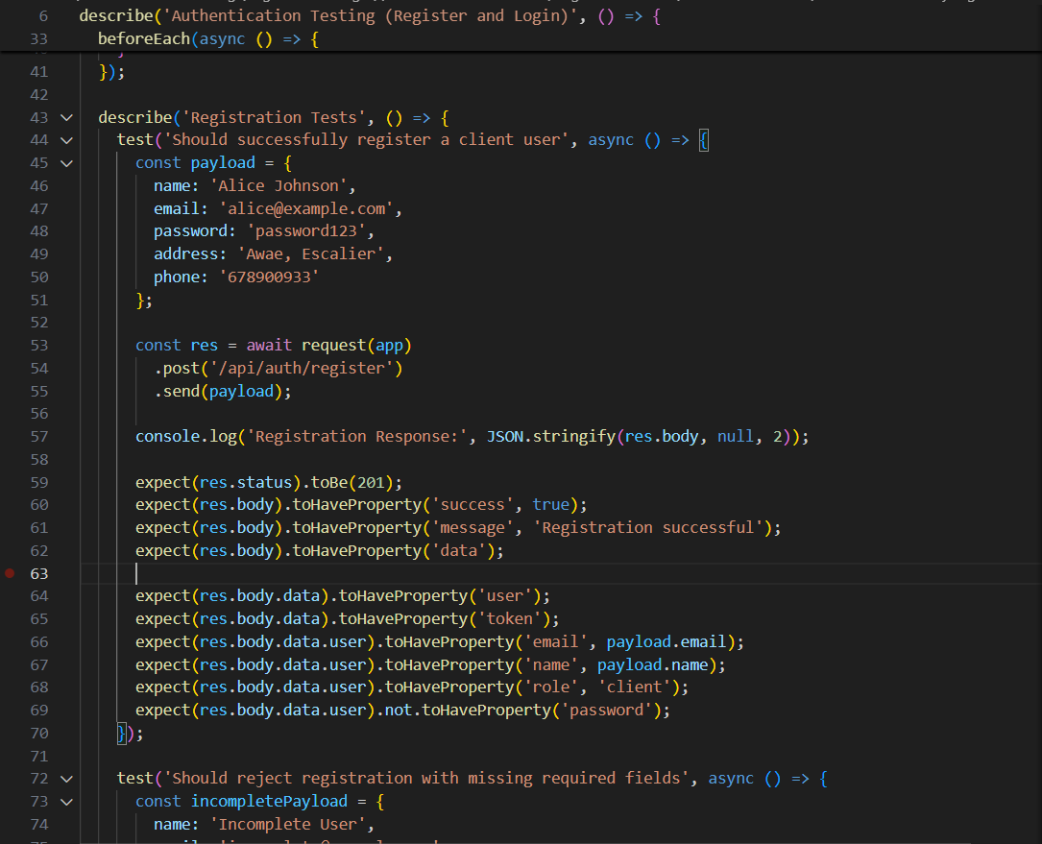
- User Registration: Demonstrates successful user registration with valid data.
Figure 35: User registration code test snippets

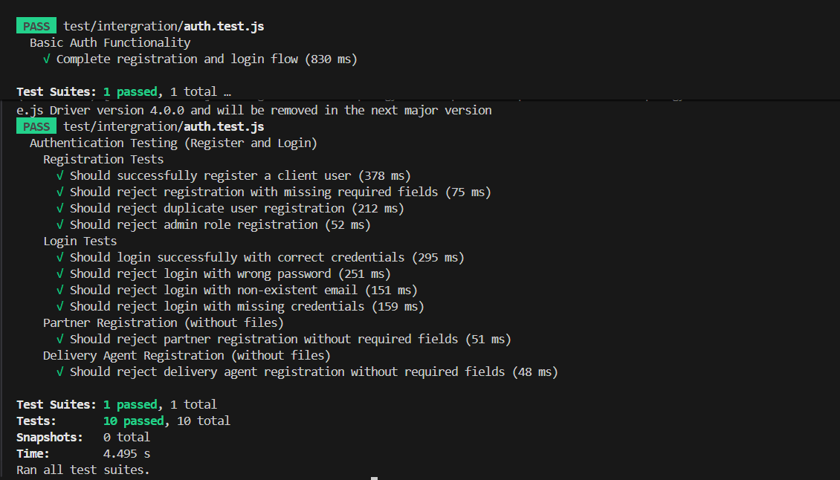
Figure 36: User registration unit test result

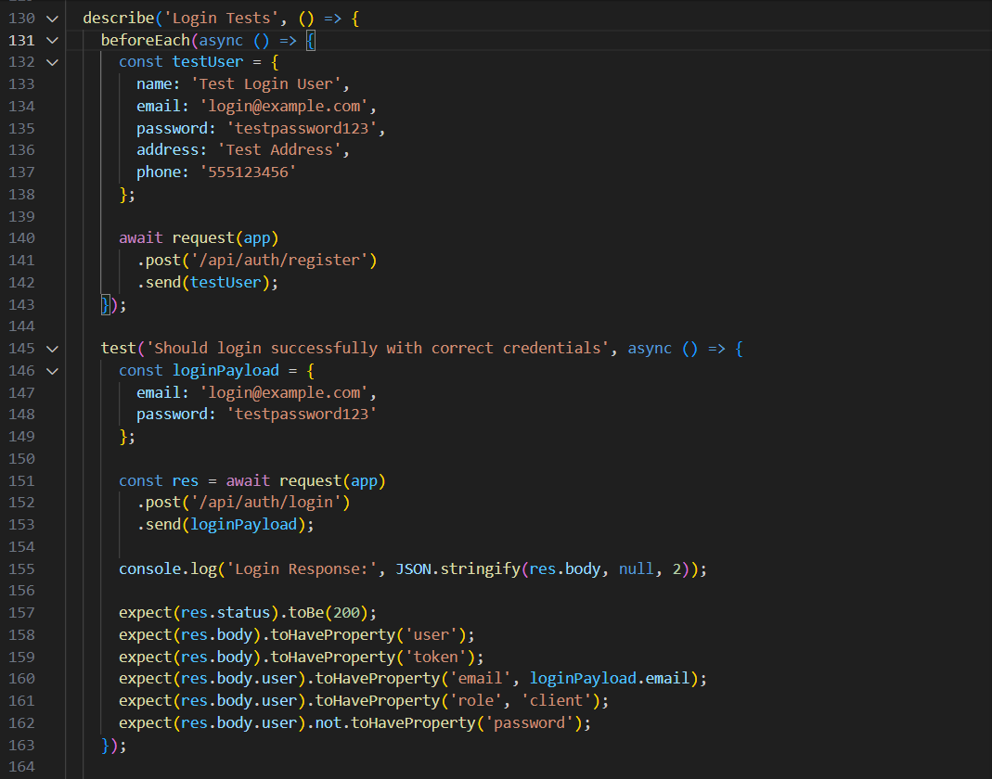
- User Authentication : Shows successful login and token generation when valid credentials are provided.
Figure 37: Authentication test code snippet

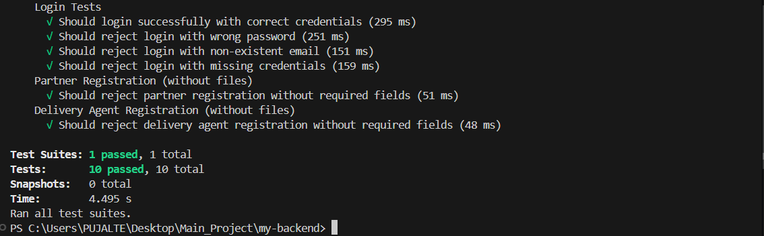
Figure 38: Registration Unit test result

CONCLUSION
Unit testing played a vital role in ensuring that core functionalities, such as user registration, login, and booking, work as expected. By focusing on isolated testing, we ensured that the app components were reliable and bug-free. In the final phase, we will provide an installation and user guide that will explain how to install and use EaseDrive.

FILE 7 : THE USER GUIDE

Preamble

A user guide explains how to use a software application in a language that a non-technical person can understand. Thus, it enables the user to easily use the application to familiarize themselves with the software and discover all its functionalities.

Content
INTRODUCTION
- DESCRIPTION OF THE APPLICATION
- USER MANUAL
CONCLUSION

INTRODUCTION
This is the ultimate stage of our report. In this phase, we will dissect the requirements for our system, the essential installation process, system, and feature accessibility in a step-by-step approach to aid first-time users with easy platform setup. Each process will be accompanied by relevant images. Subsequently, we shall present our application by showcasing the various screens.

INSTALLATION OF THE APPLICATION

System Requirements

For Developers:
- Operating System: Windows, macOS, or Linux
- Node.js: Version 14.x or later
- npm or yarn: Latest version (for package management)
- Expo CLI: Latest version (for running the app)
- MongoDB: Latest version (for database)
- Visual Studio Code or any other preferred text editor/IDE
- Git (for cloning the repository)

For Users:
- Device: Android phone
- Operating System: Requires Android 8.0 or later.
- Internet Connection

Installation Guide (For Developers)

Backend Installation
Step 1: Clone the repository
git clone https://github.com/Christ-DevOps/EASE_APP-Project.git
cd EASE_APP-Project

Step 2: Install dependencies
npm install

Step 3: Set up environment variables
- Create a .env file in the root of your backend project folder and add the following:

MONGODB_CONNECTION_STRING=mongodb://localhost:27017/Your_database_name
JWT_SECRET_KEY=your_jwt_secret_key
CLOUDINARY_CLOUD_NAME=your_cloudinary_cloud_name
CLOUDINARY_API_KEY=your_cloudinary_api_key
CLOUDINARY_CLOUD_SECRET=your_cloudinary_api_key
STRIPE_API_KEY=your_stripe_payment_api

- Replace with your variables
Step 4: Run the server
npm run dev

Frontend Installation
Step 1: Clone the repository
git clone https://github.com/Christ-DevOps/EASE_APP-Project.git
cd EASE_APP-Project

Step 2: Install dependencies
npm install

Step 3: Set up environment variables
- Create a .env file in the frontend project and configure the backend API_BASE_URL
EXPO_PUBLIC_API_BASE_URL=http://192.168.43.167:7000
EXPO_PUBLIC_GOOGLE_CLOUD_API_KEY="your_google_map_api_key"
EXPO_PUBLIC_STRIPE_PUBLISHABLE_KEY=pk_test_*
STRIPE_API_KEY=sk_test_*

- Replace with yours
Step 4: Run the expo project with Expo
npx expo start

Installing Web Version
Step 1: Clone the repository
git clone https://github.com/Christ-DevOps/EASE_APP-Project.git
cd EASE_APP-Project

Step 2: Install dependencies
npm install

Step 3: Set up environment variables
- Create a .env file in the root directory of the folder. Add the following variables:
MONGODB_CONNECTION_STRING=mongodb://localhost:27017/quickmove
JWT_SECRET_KEY=your_jwt_secret_key

Step 4: Start the app: Run the following command to start the web server for the app
npm run dev

SHOWCASE
- Registration:
  - Open the app
  - Navigate the Onboarding Screens
  - Fill in all the required fields
  - Click on submit button to create account
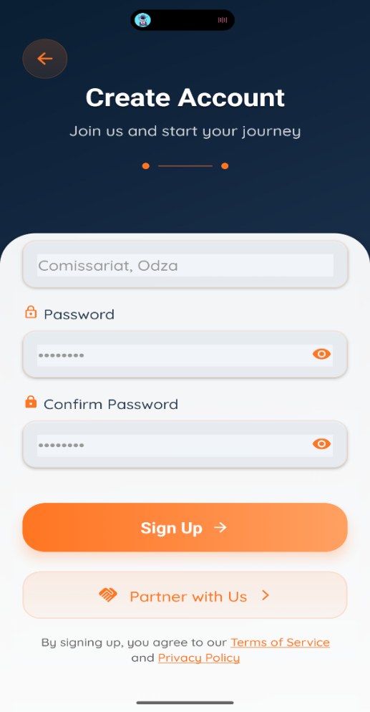
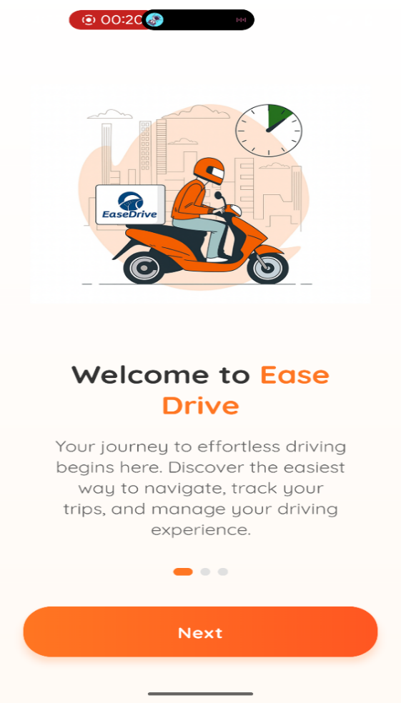

Figure 39: EaseDrive Signup screen
Figure 40: EaseDrive onboardingScreen

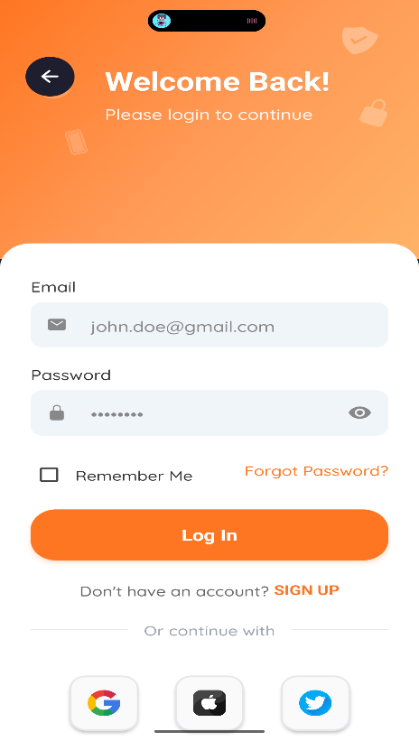
- Login:
Figure 41: EaseDrive Loginscreen
- Launch the app and enter Your Credentials.
- Click Sign-In to access your Account.

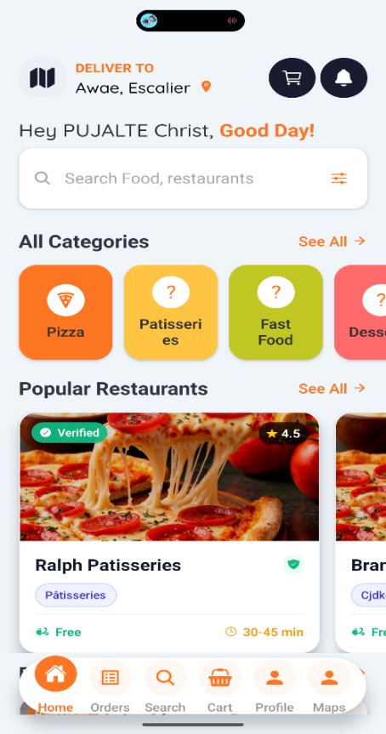
- Place an Order
- Step 1: Select a menu from Browse and click on add to cart.
- Step 2: Open the Cart then click on Place an Order button.
- Step 3: Then fill in the delivery form and submit.
- Step 4: Wait for the system to assign a delivery agent.
- Step 5: fill the payment form and submit.

PERSPECTIVES
Figure 42: EaseDrive client Homescreen

Building on the development of the core functionalities of our application, we aim to further enhance its features and extend its impact by focusing on:
- Integration of Wallet Technology enables users to store funds and make seamless in-app payments.
- Visa and International Payment Options allow visitors and diaspora users to access services securely.
- Expansion into New Sectors Extend the platform to cover grocery delivery, laundry services, and other on-demand services.
- Enhanced Security Measures Strengthen data protection, payment security, and user privacy.
- Scalability Improvements Prepare the system to handle a larger number of users and service providers.
- Continuous Feature Updates Regularly add new functionalities based on user feedback and market trends.
- Analytics and Reporting Tools Provide insights to service providers for better decision-making.
- Mobile-First Optimization Ensure the app remains fast, responsive, and user-friendly across devices.
- Introducing a reward program to recognize and incentivize top users, volunteers, or service providers.

GENERAL CONCLUSION

The development of information and communication technologies plays a crucial role in addressing socio-economic challenges. In Cameroon, where access to reliable services remains limited, our internship at REALIZE allowed us to contribute through the project “Conception and Implementation of a Service Delivery Mobile Application.”. We followed a structured process, from studying existing systems and gathering requirements to designing models with UML-2TUP in Visual Paradigm and implementing the system using React Native, Node.js, and MongoDB. The application enables users to book and track services efficiently, while service providers can manage their operations seamlessly. This project provided valuable professional experience, strengthening our teamwork, adaptability, and problem-solving skills. It demonstrates how computer science can drive social and economic development. Future improvements will focus on expanding features, enhancing security, and ensuring scalability, laying a strong foundation for both the platform and our professional growth.

ANNEXES

BIBLIOGRAPHY

REFERENCES

WEBOGRAPHY

VIDEOGRAPHY

TABLE OF CONTENTS

